**SQL ASSIGNMENT SET 1**

**Sample Dataset 1**

**Q1**. Query all columns for all American cities in the CITY table with populations larger than 100000. The Country-Code for America is USA.

Sol) **select * from city where CountryCode='USA' and population>100000;**

**First of all, I have created a database named ‘assignment’ and then created a table inside it named ‘City’. Then Inserted records using insert functions and then performed the desired query.**

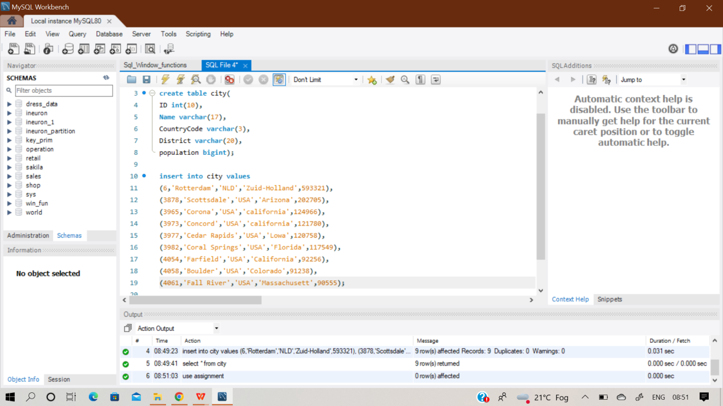

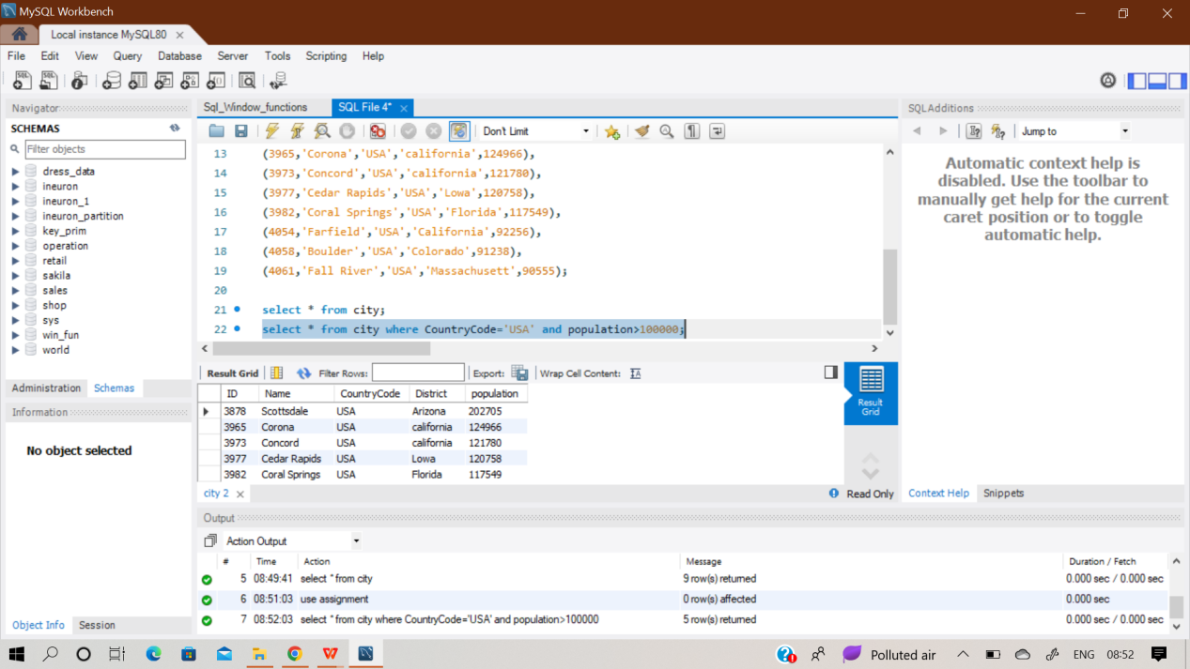

**Q2**. Query the NAME field for all American cities in the CITY table with populations larger than 120000.

Sol) **select name from city where CountryCode='USA' and population>120000;**

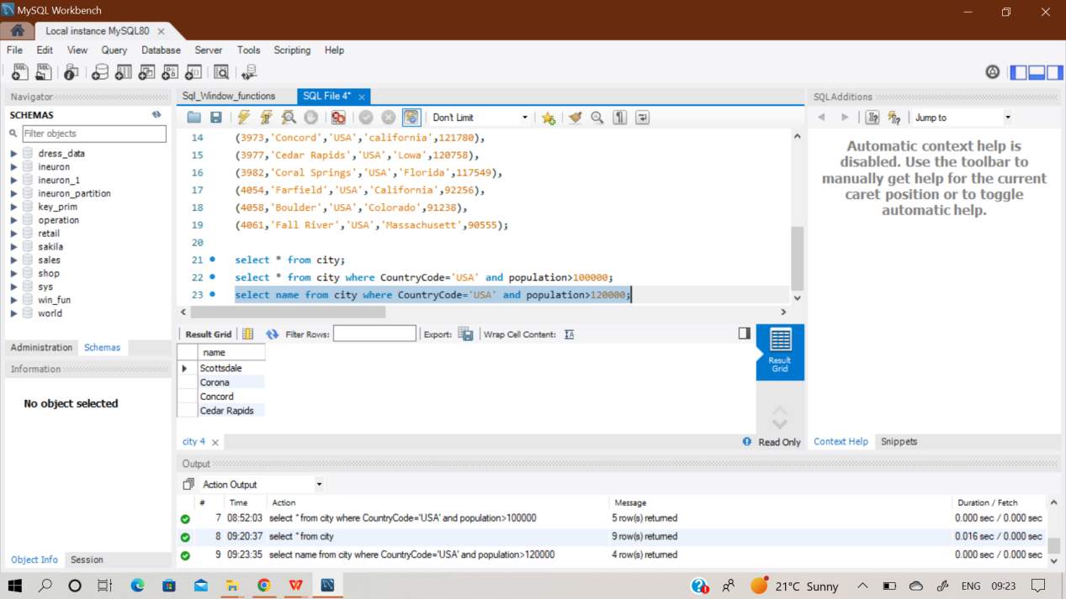

**Q3.** Query all columns (attributes) for every row in the CITY table.

Sol) **Select * from City;**

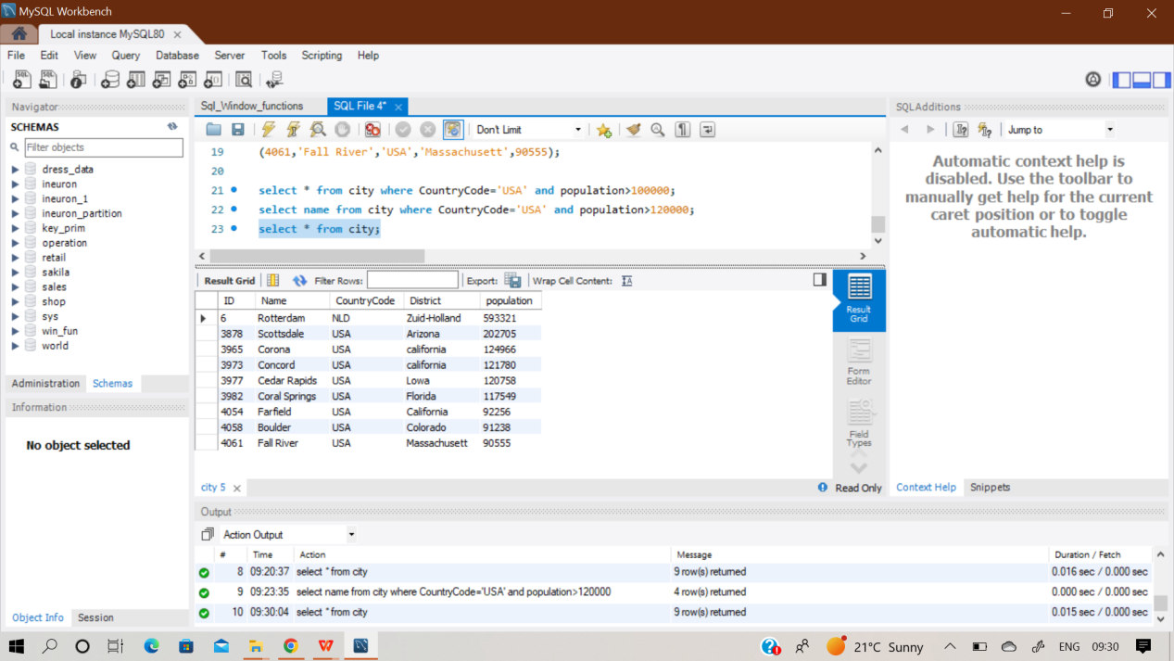

**Q4)** Query all columns for a city in CITY with the ID 1661.

**Sol) Select * from city where ID = 1661;**

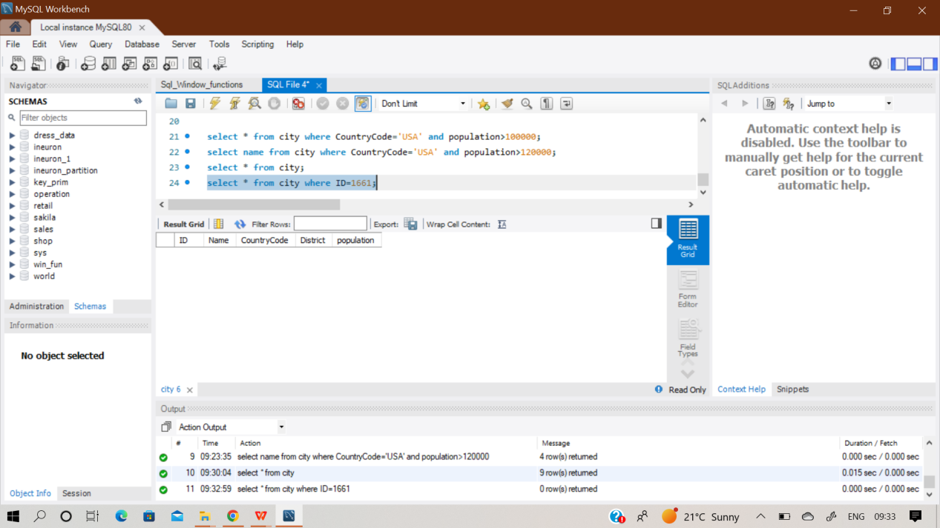

**Output - No rows returned.**

**Q5**. Query all attributes of every Japanese city in the CITY table. The COUNTRYCODE for Japan is JPN.

Sol) **select * from city where CountryCode='JPN';**

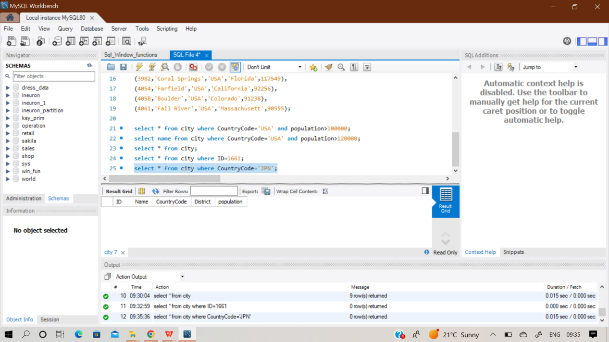

**Output - No rows returned.**

**Q6)** Query the names of all the Japanese cities in the CITY table. The COUNTRYCODE for Japan is JPN.

Sol) **Select name from City where CountryCode=’JPN’;**

**Output - No rows returned.**

**Sample Dataset 2**

First of all , I created a new table ‘station’ and then inserted the records in it using multi-insert statement. The glimpse of it is shown in the image.

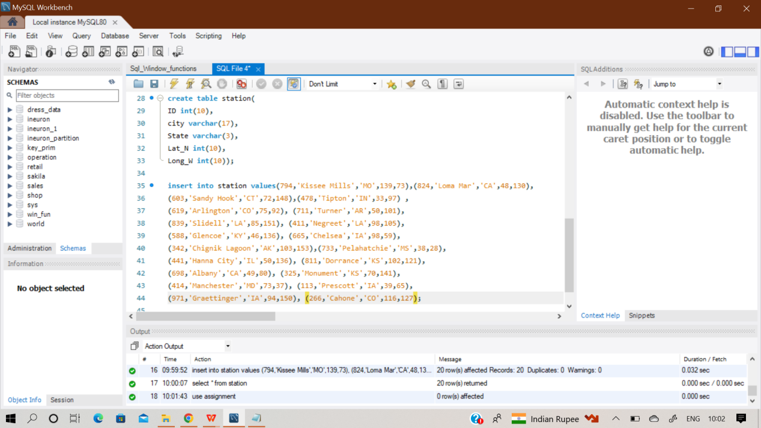

**Q8.** Query a list of CITY names from STATION for cities that have an even ID number. Print the results in any order, but exclude duplicates from the answer.

**Sol) Select distinct(city) from station where MOD(ID,2)=0**

**order by city;**

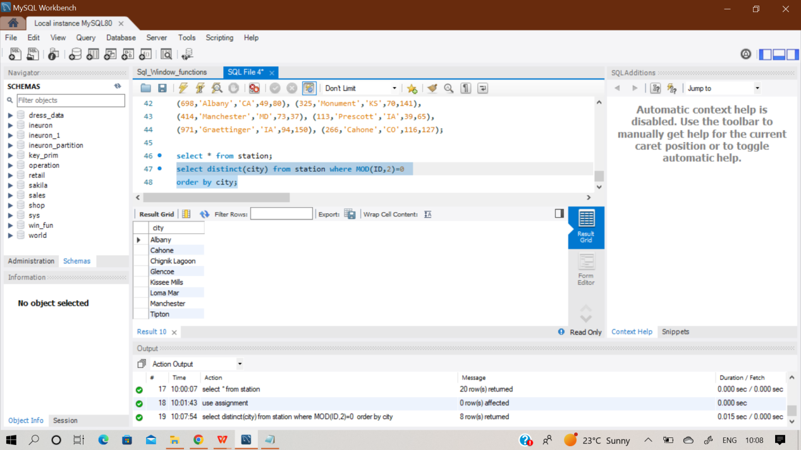

**Q9)** Find the difference between the total number of CITY entries in the table and the number of distinct CITY entries in the table.

**Sol) select (count(*) - count(distinct city)) as Difference**

**from station;**

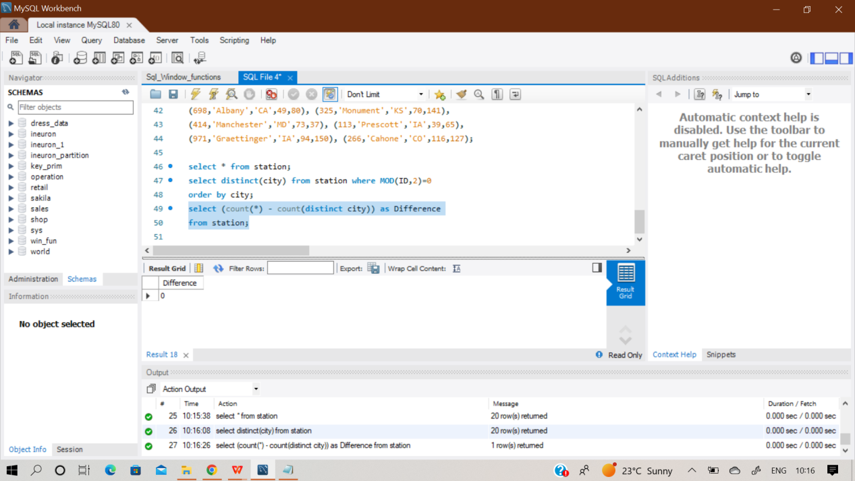

**There is zero difference between total no of cities and distinct cities. All the city records in the station table are unique.**

Q10) Query the two cities in STATION with the shortest and longest CITY names, as well as their respective lengths (i.e.: number of characters in the name). If there is more than one smallest or largest city, choose the one that comes first when ordered alphabetically.

Sol) **(Select CITY,LENGTH(CITY) as Min from STATION**

**order by Length(CITY) asc, CITY limit 1)**

**union**

**(Select CITY,LENGTH(CITY) as Max from STATION order by Length(CITY) desc, CITY limit 1);**

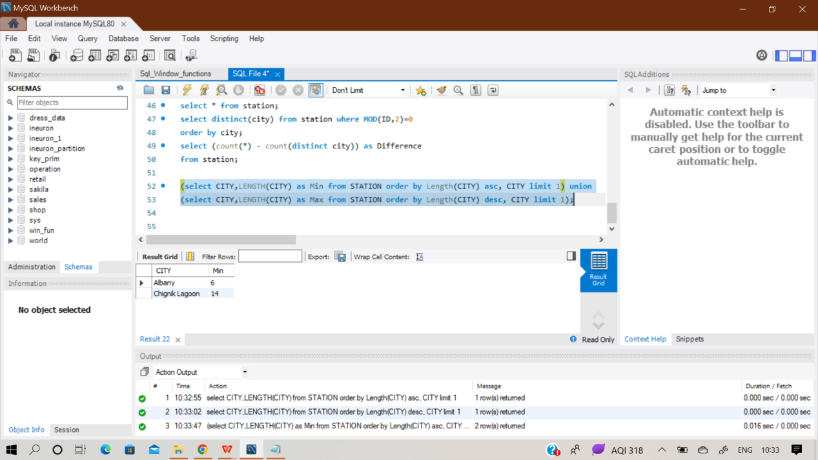

Q11) Query the list of CITY names starting with vowels (i.e., a, e, i, o, or u) from STATION. Your result cannot contain duplicates.

Sol) **Select Distinct(city) from station**

**where city like 'a%' OR CITY LIKE 'e%' OR CITY LIKE 'i%'**

**OR CITY LIKE 'o%' OR CITY LIKE 'u%';**

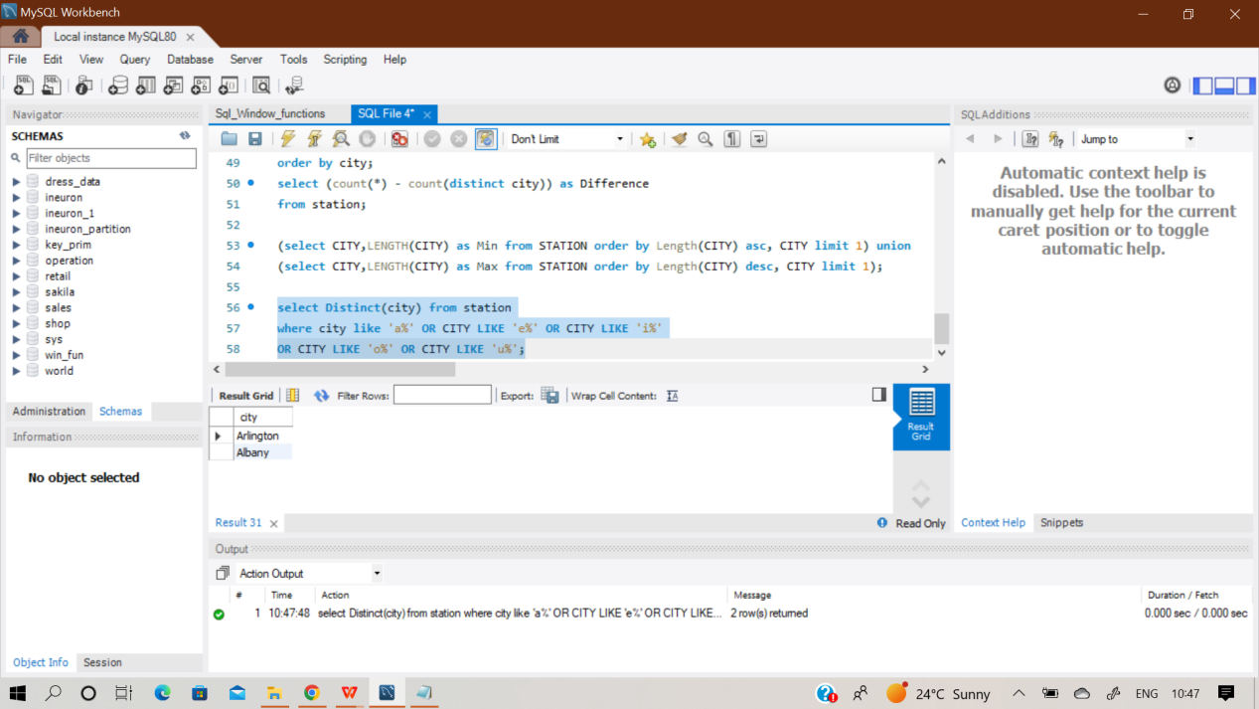

Q12) Query the list of CITY names ending with vowels (a, e, i, o, u) from STATION. Your result cannot contain duplicates.

Sol) **Select Distinct(city) from station**

**where city like '%a' OR CITY LIKE '%e' OR CITY LIKE '%i'**

**OR CITY LIKE '%o' OR CITY LIKE '%u';**

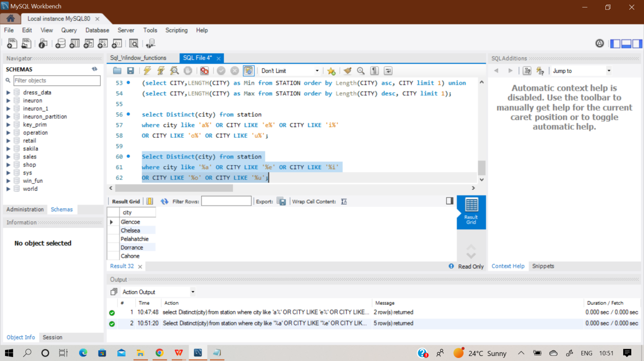

Q13) Query the list of CITY names from STATION that do not start with vowels. Your result cannot contain duplicates.

**Select Distinct(city) from station where city not like 'a%' and CITY not LIKE 'e%' and CITY not LIKE 'i%' and CITY not LIKE 'o%' and CITY not LIKE 'u%';**

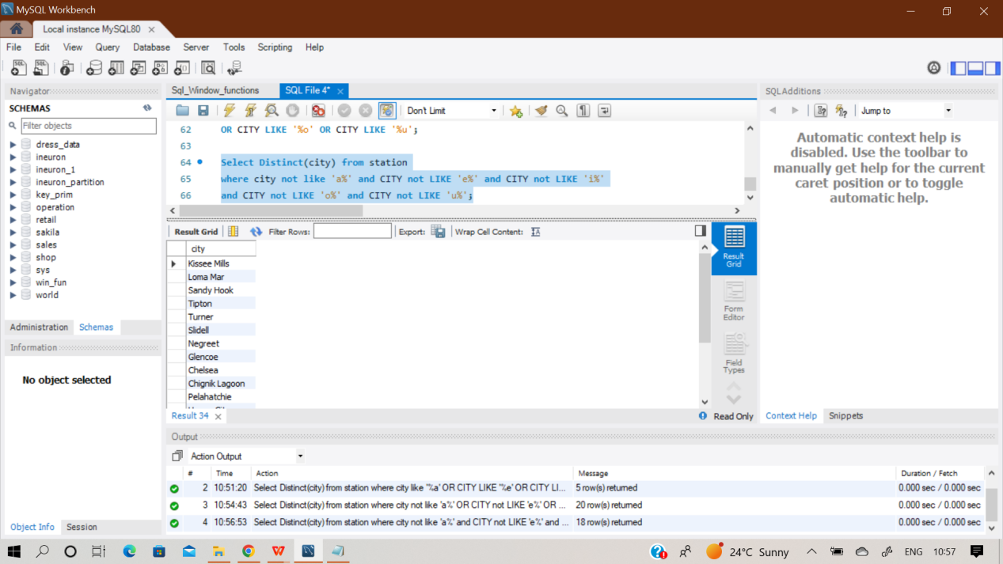

Q15) Query the list of CITY names from STATION that do not start with vowels or do not end with vowels. Your result cannot contain duplicates.

**Sol) Select distinct city from station where**

**lower(substr(city,1,1)) not in ('a','e','i','o','u')**

**or**

**lower(substr(city, length(city),1)) not in ('a','e','i','o','u');**

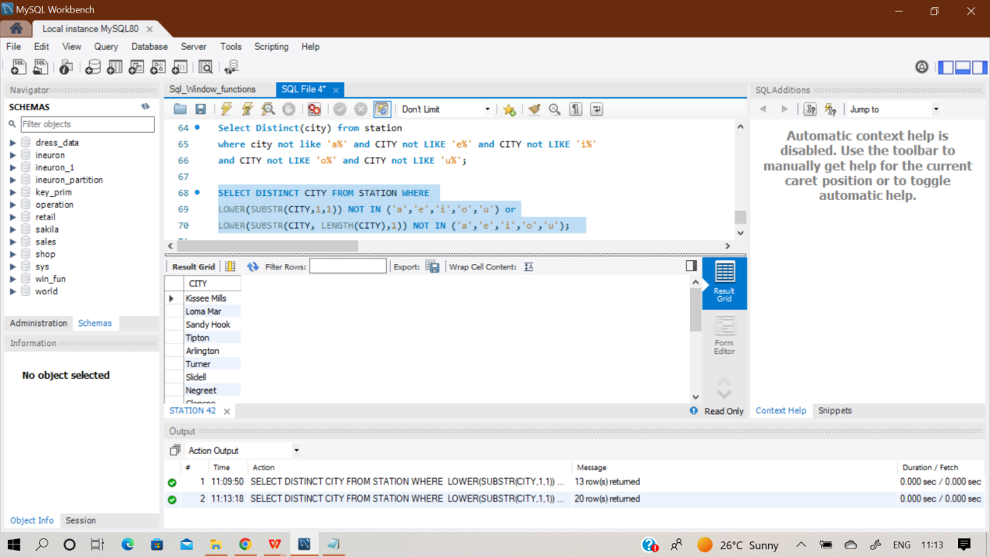

**Q16)** Query the list of CITY names from STATION that do not start with vowels or do not end with vowels. Your result cannot contain duplicates.

**Sol) Select distinct city from station where**

**lower(substr(city,1,1)) not in ('a','e','i','o','u') and**

**lower(substr(city, length(city),1)) not in ('a','e','i','o','u');**

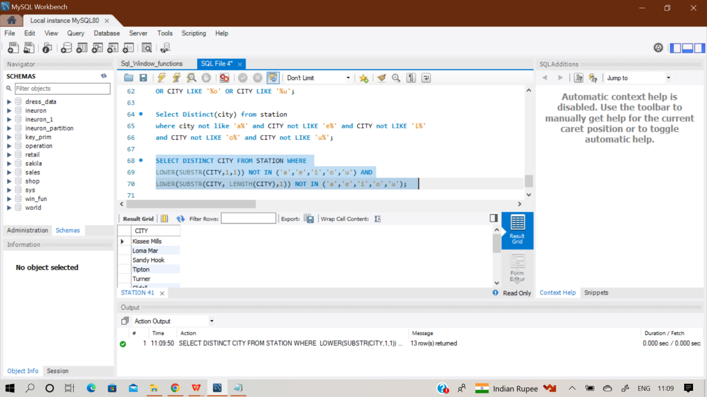

**Q17)** Table: Product

|  |  |
| --- | --- |
| **Column Name** | **Type** |
| Product_id | int |
| Product_name | varchar |
| Unit_price | int |

product_id is the primary key of this table.

Each row of this table indicates the name and the price of each product

Table: Sales

|  |  |
| --- | --- |
| Column Name | Type |
| Seller_id | int |
| Product_id | int |
| Buyer_id | int |
| Sales_date | date |
| Quantity | int |
| Price | int |

This table has no primary key, it can have repeated rows. product_id is a foreign key to the Product table. Each row of this table contains some information about one sale.

**Write an SQL query that reports the products that were only sold in the first quarter of 2019. That is, between 2019-01-01 and 2019-03-31 inclusive.**

First of all , I have created both tables Product and Sales and then inserted the records manually using insert command. The glimpse of it is shown below.

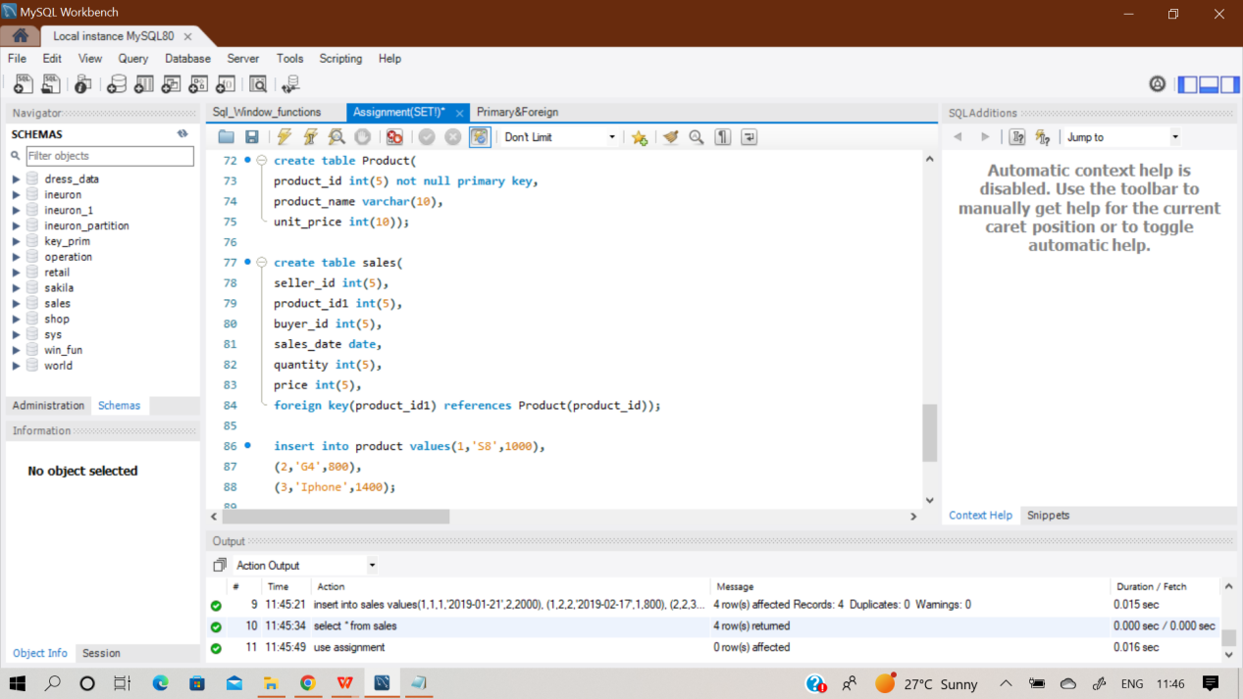

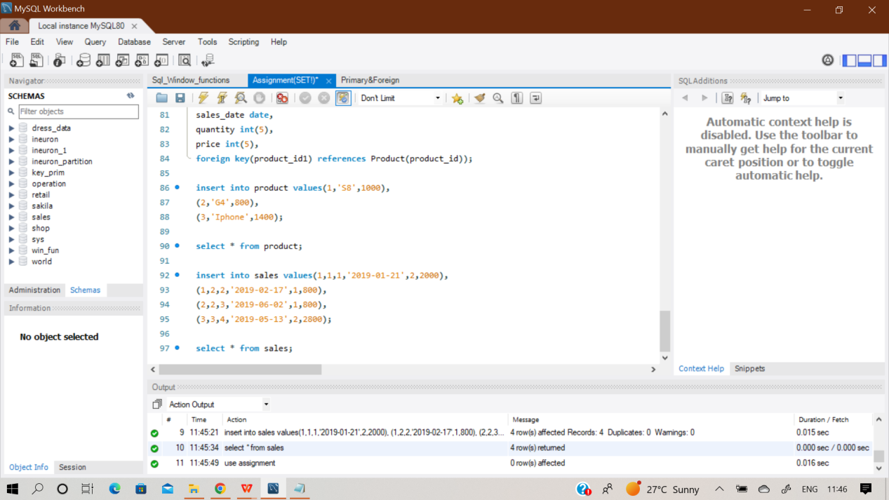

**Sol) Select distinct product_id,product_name from product**

**where product_id in (select product_id1 from sales**

**where sales_date between '2019-01-01' AND '2019-03-31');**

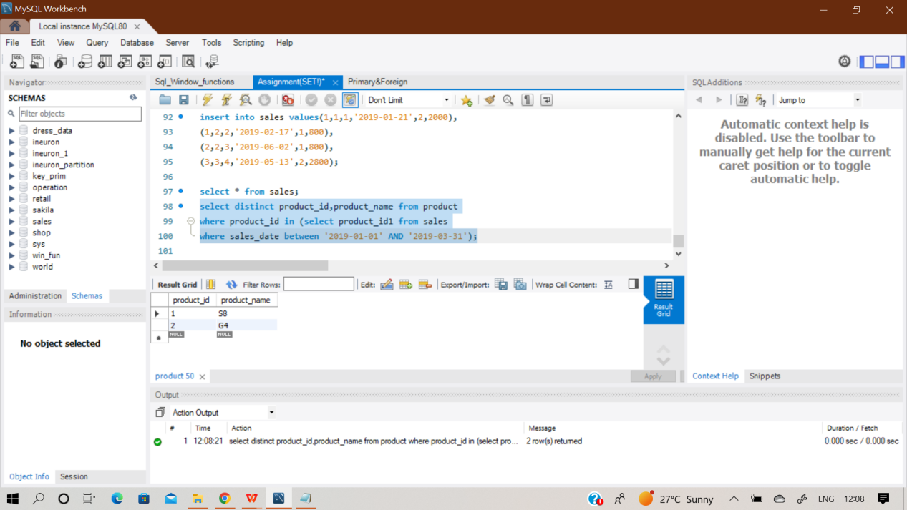

**Q18) Table Views:**

|  |  |
| --- | --- |
| **Column_Name** | **Type** |
| Article_id | int |
| Author_id | int |
| Viewer_id | int |
| View_date | date |

**Write an SQL query to find all the authors that viewed at least one of their own articles. Return the result table sorted by id in ascending order. Return the resulted table in ascending order.**

**Sol) First of all , I created a table ‘views’ and then inserted the records manually using insert function.**

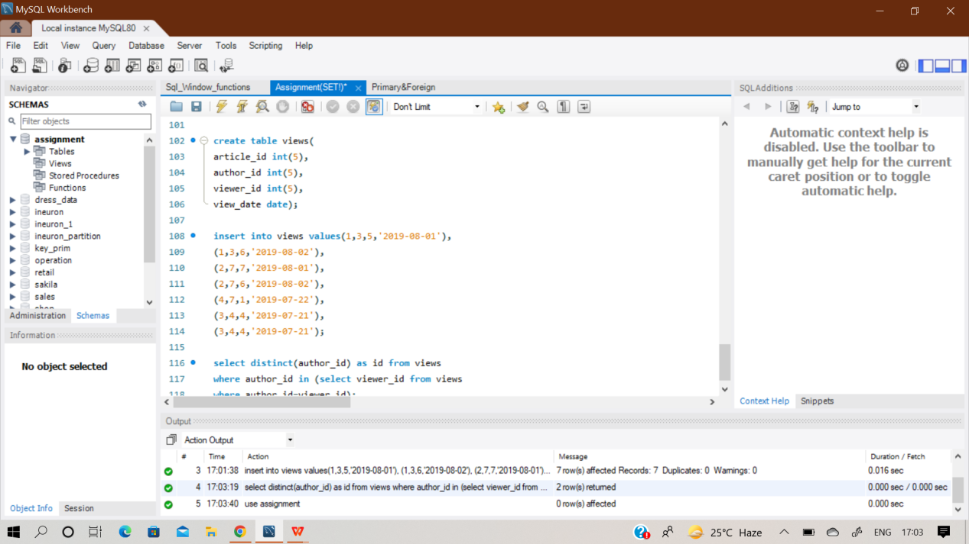

**Input:**

|  |  |  |  |
| --- | --- | --- | --- |
| **Article_id** | **Author_id** | **Viewer_id** | **View_date** |
| 1 | 3 | 5 | 2019-08-01 |
| 1 | 3 | 6 | 2019-08-02 |
| 2 | 7 | 7 | 2019-08-01 |
| 2 | 7 | 6 | 2019-08-02 |
| 4 | 7 | 1 | 2019-07-22 |
| 3 | 4 | 4 | 2019-07-21 |
| 3 | 4 | 4 | 2019-07-21 |

**Output:**

|  |
| --- |
| **id** |
| **4** |
| **7** |

**select distinct(author_id) as id from views**

**where author_id in (select viewer_id from views**

**where author_id=viewer_id)**

**Order by author_id;**

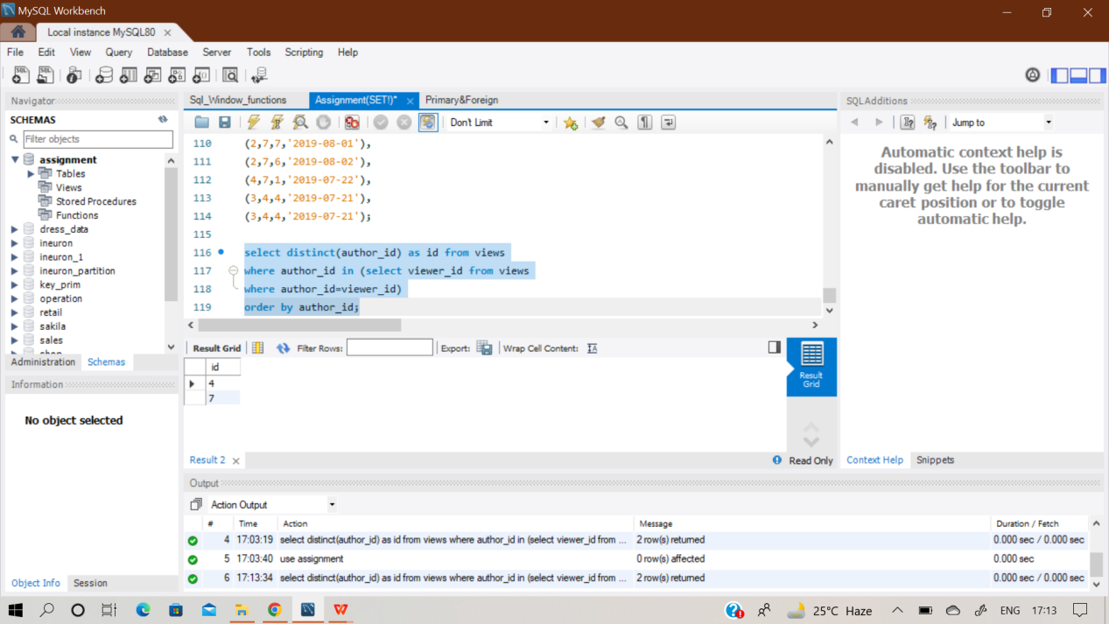

**Q19) The table holds information about food delivery to customers that make orders at some date and specify a preferred delivery date (on the same order date or after it). If the customer's preferred delivery date is the same as the order date, then the order is called immediately; otherwise, it is called scheduled. Write an SQL query to find the percentage of immediate orders in the table, rounded to 2 decimal places.**

**Sol) First of all , I created a table ‘delivery’ and then inserted the records manually using insert function.**

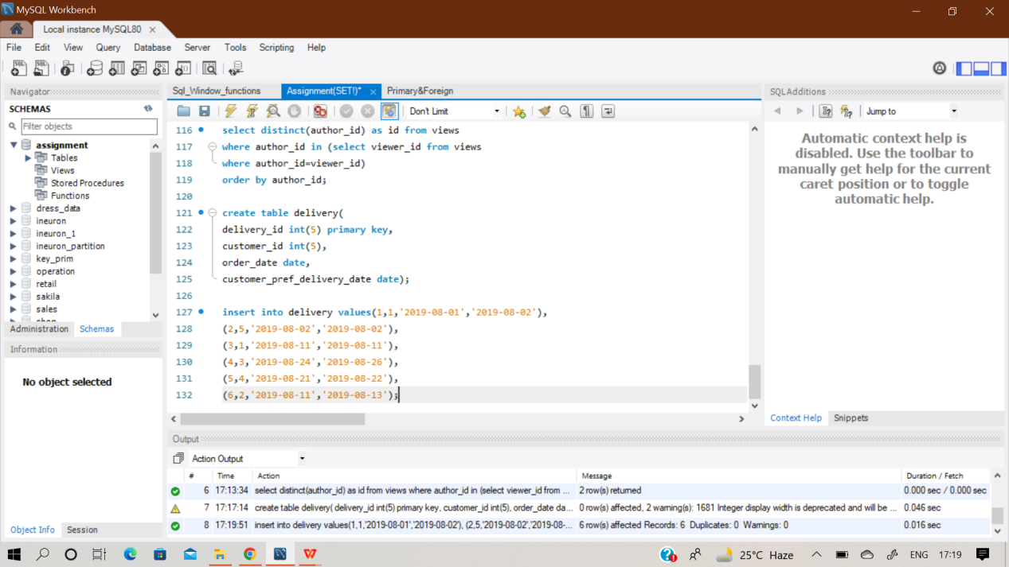

**with cte as (select * from**

**(select delivery_id,customer_id,order_date,customer_pref_delivery_date,**

**(Case when order_date=customer_pref_delivery_date then 1 else 0 end) as immediate,**

**RANK() OVER(PARTITION BY customer_id ORDER BY order_date) as first_order**

**from delivery)x)**

**SELECT**

**round(sum(immediate) *100 / count(first_order),2) as immediate_percentage from cte;**

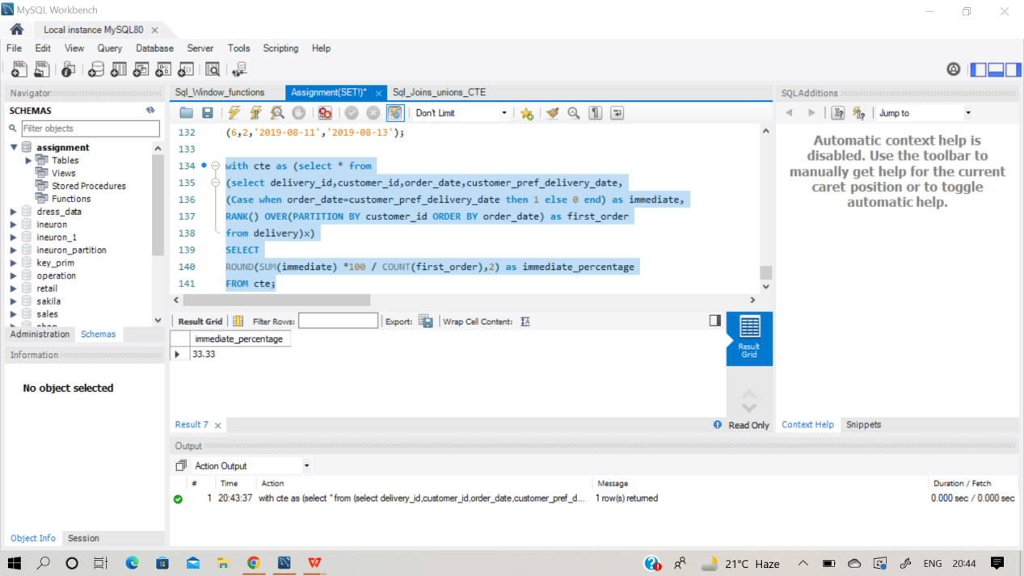

**Q20) A company is running Ads and wants to calculate the performance of each Ad. Performance of the Ad is measured using Click-Through Rate (CTR) where:Write an SQL query to find the ctr of each Ad. Round ctr to two decimal points. Return the result table ordered by ctr in descending order and by ad_id in ascending order in case of a tie.**

**Input:**

|  |  |
| --- | --- |
| **Column** | **Data type** |
| Ad_id | int |
| User_id | int |
| Action | enum |

**Output:**

|  |  |
| --- | --- |
| **Ad_id** | **CTR** |
| 1 | 66.67 |
| 3 | 50 |
| 2 | 33.33 |
| 5 | 0 |

**First of all , I have created a table ‘ads’ and then inserted the data manually using multi insert function.**

**Here, We have to Calculate Click Through Rate(CTR) which is used to calculate performance of the ads. The formula to calculate it is:**

**CTR = {0, Ad(Total clicks)/Ad(total clicks) + Ad(Total views)}**

**Note- Ignored ads is not considered.**

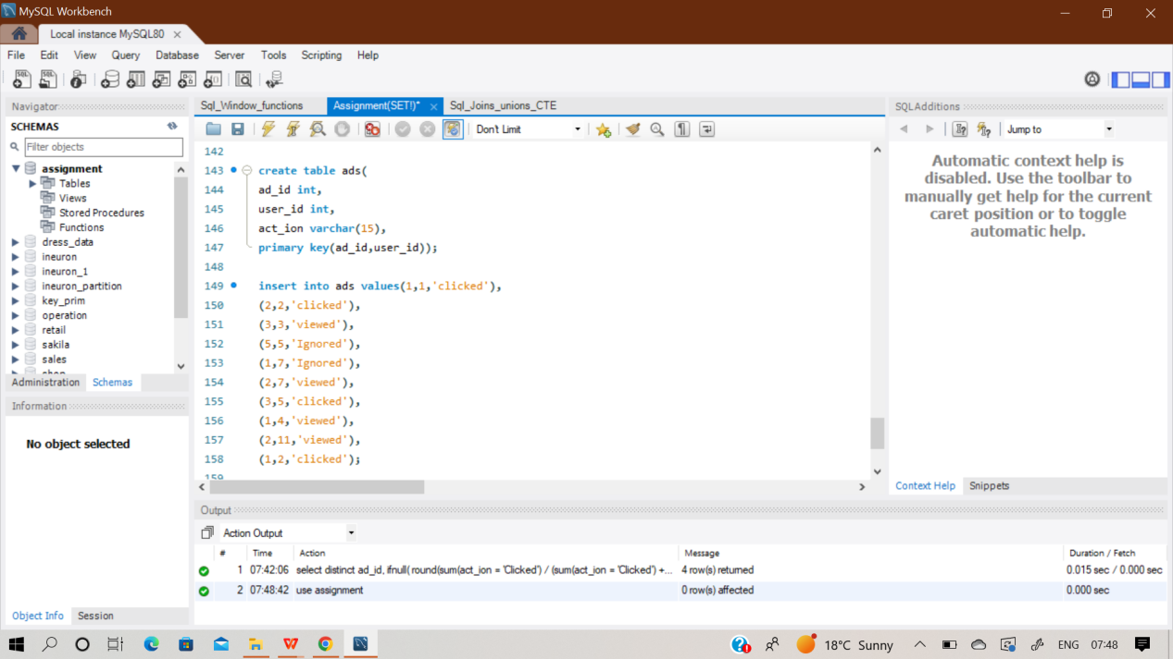

**Select distinct ad_id, ifnull(**

**round(sum(act_ion = 'Clicked') / (sum(act_ion = 'Clicked') + sum(act_ion = 'Viewed')) * 100, 2),0)**

**as ctr**

**from ads**

**group by ad_id**

**order by ctr desc, ad_id;**

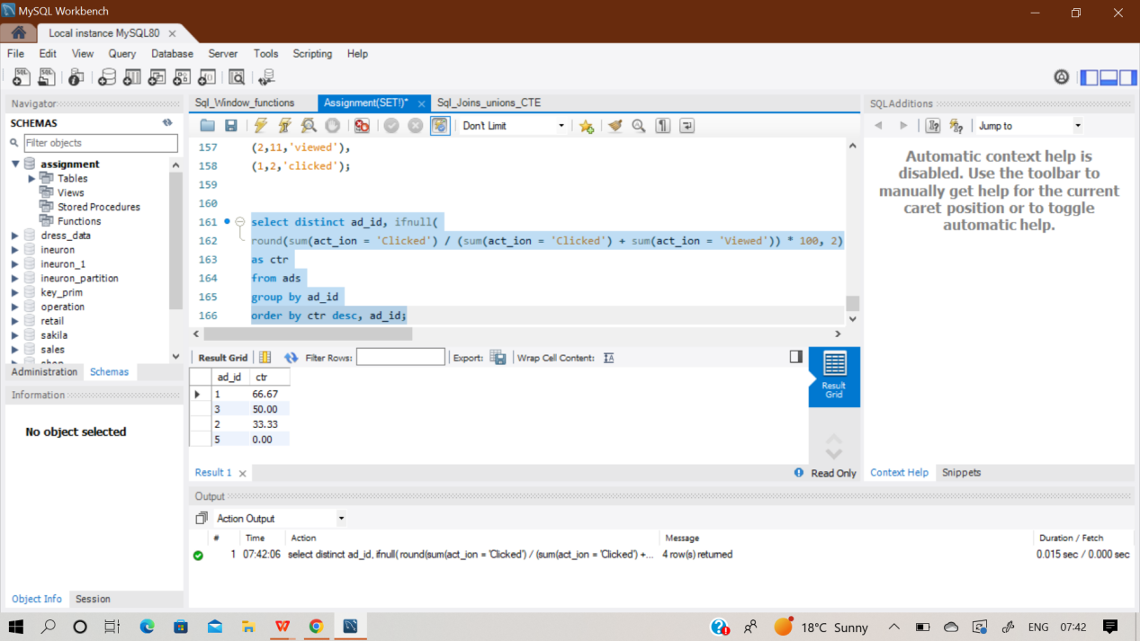

**Q21) Table: Employee**

|  |  |
| --- | --- |
| **Column Name** | **Type** |
| Employee_id | int |
| Team_id | int |

Employee_id is the primary key for this table. Each row of this table contains the ID of each employee and their respective team. Write an SQL query to find the team size of each of the employees. Return result table in any order. The query result format is in the following example.

**Output:**

|  |  |
| --- | --- |
| **Employee_id** | **Team_size** |

**Sol) As similar to above procedures, I have created an empty table first named ‘employee’ and then added records in it.And then performed the desired query over it. Here we have to find out team size of each employee of the table.**

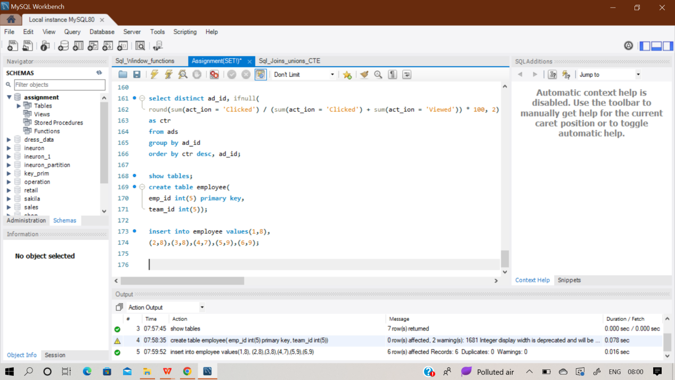

**Select emp_id,**

**count(team_id) over (partition by team_id) as team_size**

**from employee**

**order by emp_id;**

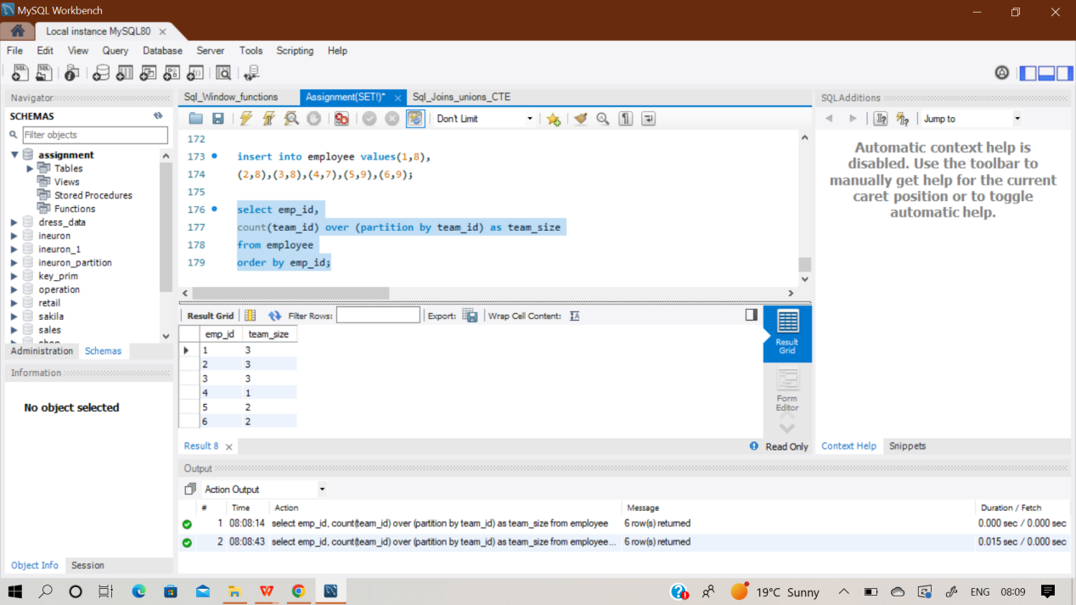

**Q22) Write an SQL query to find the type of weather in each country for November 2019.**

**The type of weather is:**

**● Cold if the average weather_state is less than or equal 15,**

**●**

**Hot if the average weather_state is greater than or equal to 25, and**

**● Warm otherwise.**

**Return result table in any order**

**Input: Countries table**

|  |  |
| --- | --- |
| **Column Name** | **Type** |
| Country_id | int |
| Country_name | varchar |

**Weather Table:**

|  |  |
| --- | --- |
| **Column Name** | **Type** |
| Country_id | int |
| Weather state | int |
| day | date |

**Output:**

|  |  |
| --- | --- |
| **Country Name** | **Weather Type** |
| USA | Cold |
| Australia | Cold |
| Peru | Hot |
| Morocco | Hot |
| China | Warm |

**Sol) At first, I created two empty table named ‘countries’ and ‘weather’ and then inserted the records row by row. Here we have to find out the Country name and Weather type of every country.**

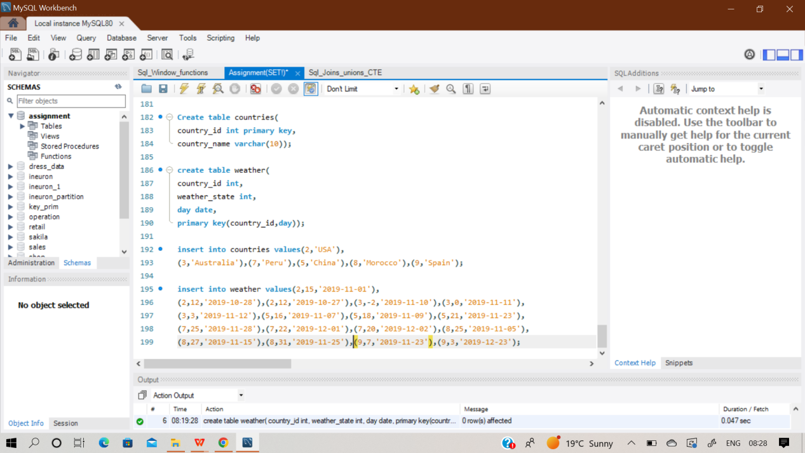

**select country_name,**

**(case when avg(weather_state)<=15 then 'cold'**

**when avg(weather_state)>=25 then 'hot'**

**else 'warm'**

**end) as 'weather_type'**

**from countries c inner join weather w**

**on c.country_id = w.country_id**

**where w.day between '2019-11-01' and '2019-11-30'**

**group by c.country_id;**

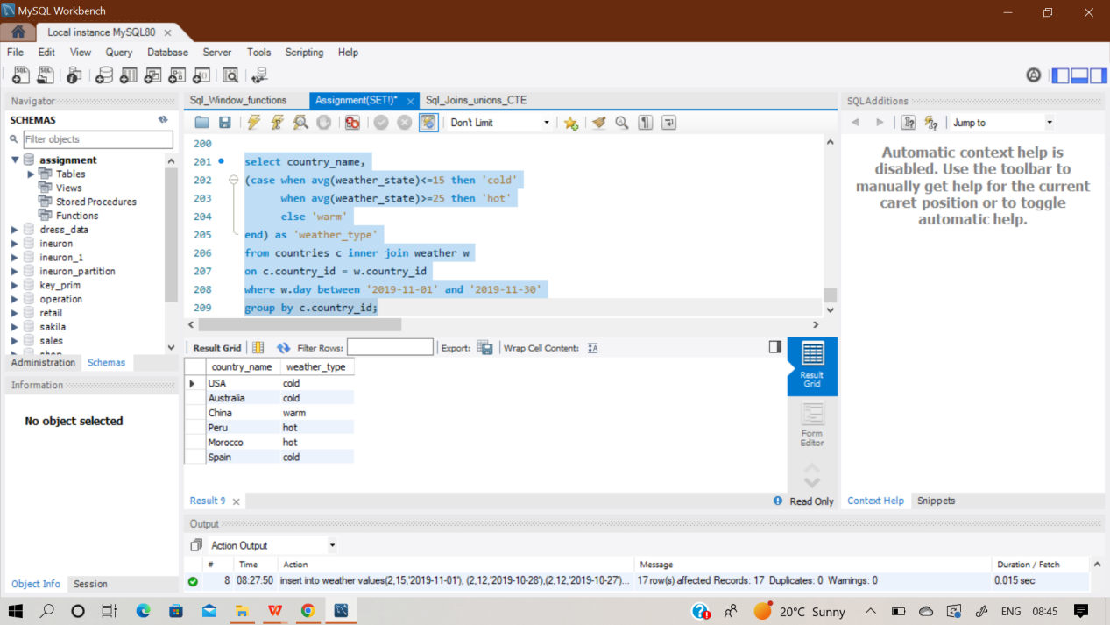

**Q23) Write an SQL query to find the average selling price for each product. average_price should be**

**rounded to 2 decimal places.**

**Return the result table in any order**

**Input:**

**Prices Table**

|  |  |
| --- | --- |
| **Column Name** | **Type** |
| Product_id | int |
| Start_date | date |
| End_date | date |
| price | int |

**UnitsSold Table**

|  |  |
| --- | --- |
| **Column Name** | **Type** |
| Product_id | int |
| purchase_date | date |
| Units | int |

**Output:**

|  |  |
| --- | --- |
| **Product_id** | **Average_price** |
| 1 | 6.96 |
| 2 | 16.96 |

Sol) Initially,I created two empty tables named ‘Price’ and ‘UnitsSold’

And then inserted records in it. And then performed the desired query.

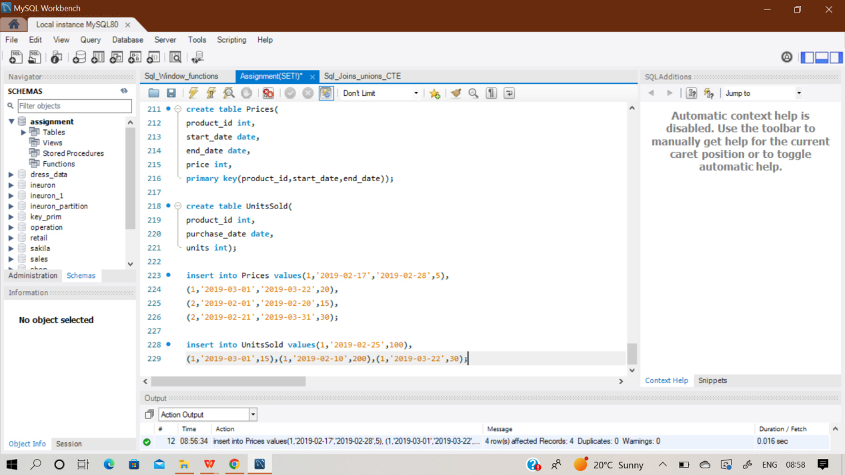

**select u.product_id,**

**round(sum(p.price * u.units)/sum(u.units),2) as average_price**

**from prices p left join UnitsSold u**

**on p.product_id = u.product_id and (u.purchase_date between p.start_date And p.end_date) group by u.product_id;**

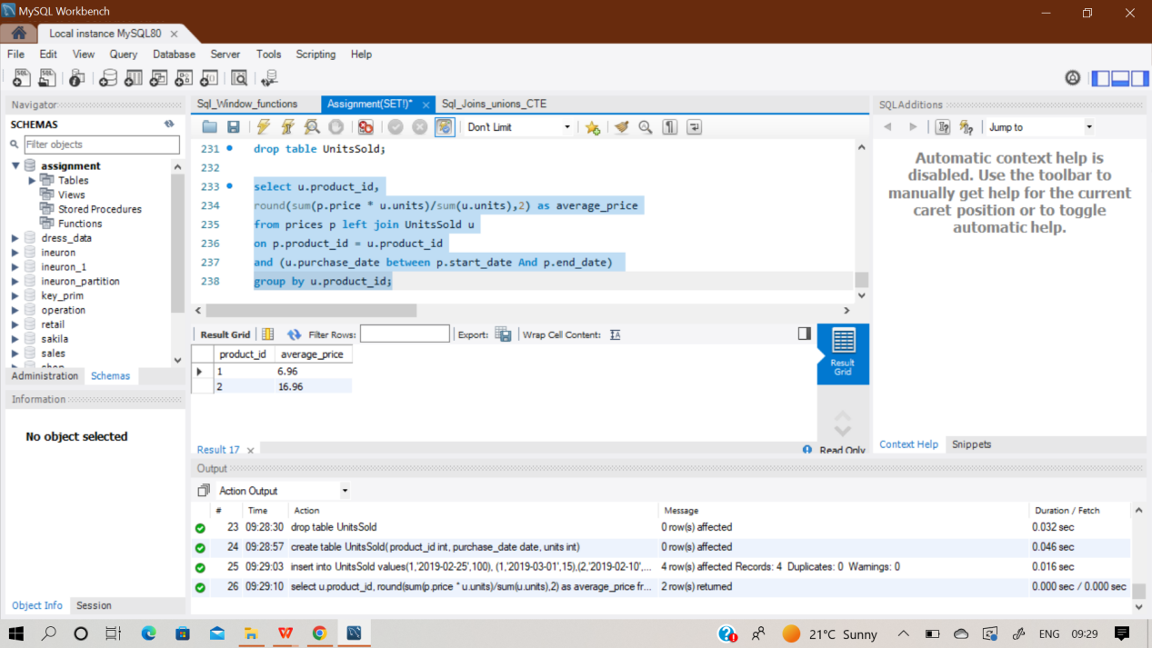

**Q24)** **Input:**

**Activity Table**

|  |  |
| --- | --- |
| **Column Name** | **Type** |
| Player_id | int |
| Device_id | int |
| Event_date | date |
| Games_played | int |

(player_id, event_date) is the primary key of this table.

This table shows the activity of players of some games.

Each row is a record of a player who logged in and played a number of games (possibly 0) before logging out on someday using some device.

**Write an SQL query to report the first login date for each player.**

**Output:**

|  |  |
| --- | --- |
| **Player_id** | **First_login** |
| 1 | 2016-03-01 |
| 2 | 2017-06-25 |
| 3 | 2016-03-02 |

Sol) Initially, I created a empty table ‘Activity’ and then loaded the data inside it.

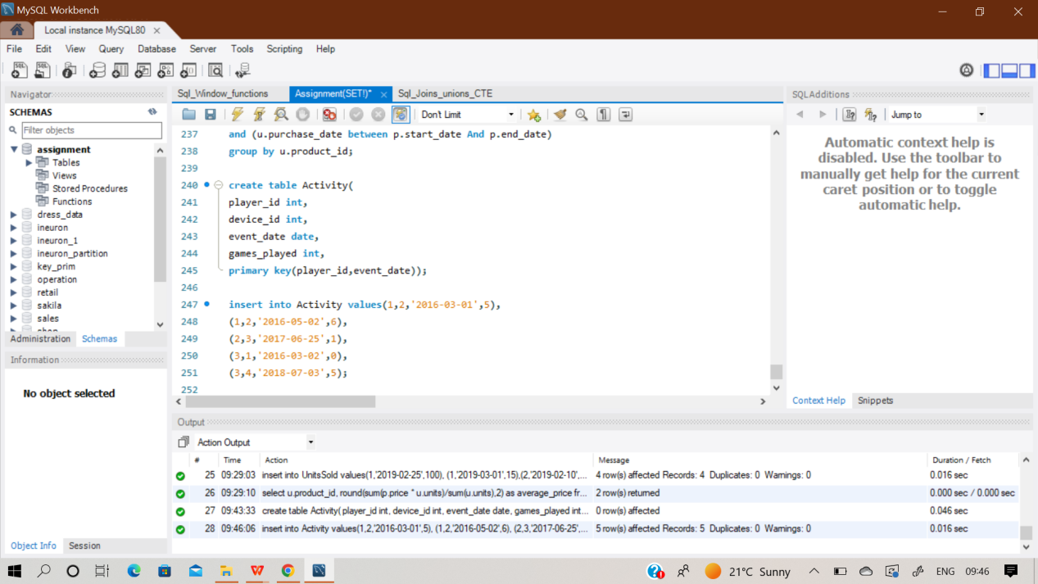

And then performed the desired query over it.

**select player_id,MIN(event_date) as first_login**

**from activity**

**group by player_id;**

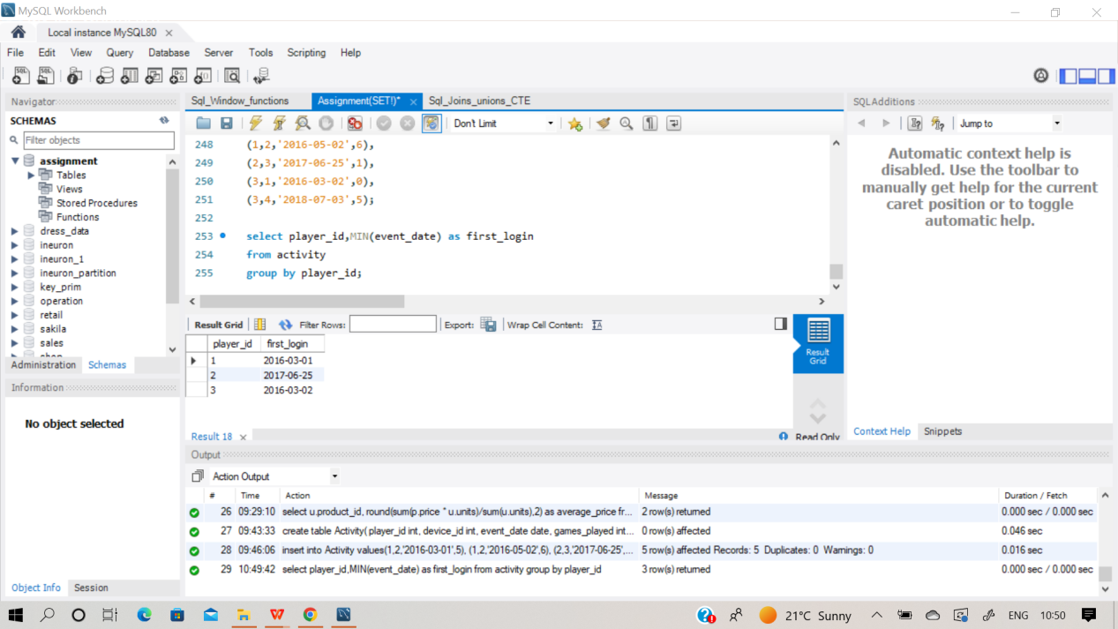

**Q25) Write a SQL query to report the device that is first logged in for each player. Return the table in any order.**

**Output:**

|  |  |
| --- | --- |
| **Player_id** | **Device_id** |
| 1 | 2 |
| 2 | 3 |
| 3 | 1 |

**Sol) select distinct(player_id),**

**FIRST_VALUE(device_id) OVER (PARTITION BY player_id ORDER BY event_date ASC) AS device_id**

**from activity;**

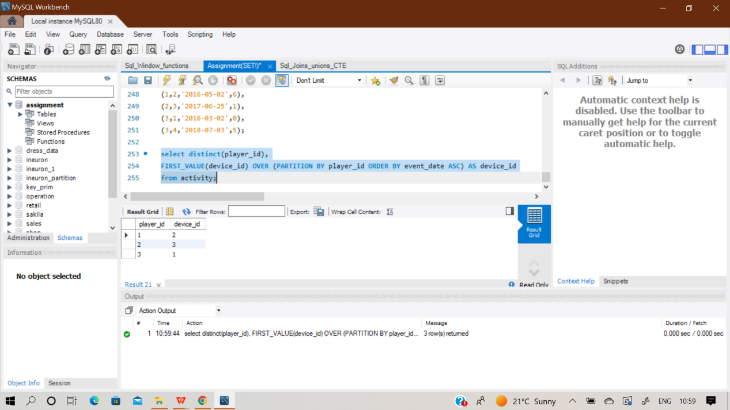

**Q26) Input:**

**Products Table**

|  |  |
| --- | --- |
| **Column Name** | **Type** |
| Product_id | int |
| Product_name | varchar |
| Product_category | varchar |

product_id is the primary key for this table. This table contains data about the company's products.

**Orders Table**

|  |  |
| --- | --- |
| **Column Name** | **Type** |
| Product_id | int |
| Order date | date |
| unit | int |

There is no primary key for this table. It may have duplicate rows.

product_id is a foreign key to the Products table. unit is the number of products ordered in order_date.

**Write an SQL query to get the names of products that have at least 100 units ordered in February 2020 and their amount. Return result table in any order. The query result format is in the following example.**

**Output:**

|  |  |
| --- | --- |
| **Product_name** | **Unit** |
| Leetcode solutions | 130 |
| Leetcode kit | 100 |

Sol) Create two empty table ‘Products’ & ‘Orders’ table and then inserted records in it row by row. And then perform the desired query.

**Select p.product_name, sum(o.unit) as unit from products p**

**left join orders o**

**on p.product_id = o.product_id1**

**where o.order_date Between '2020-02-01' And '2020-02-29'**

**group by p.product_name**

**having sum(o.unit)>=100;**

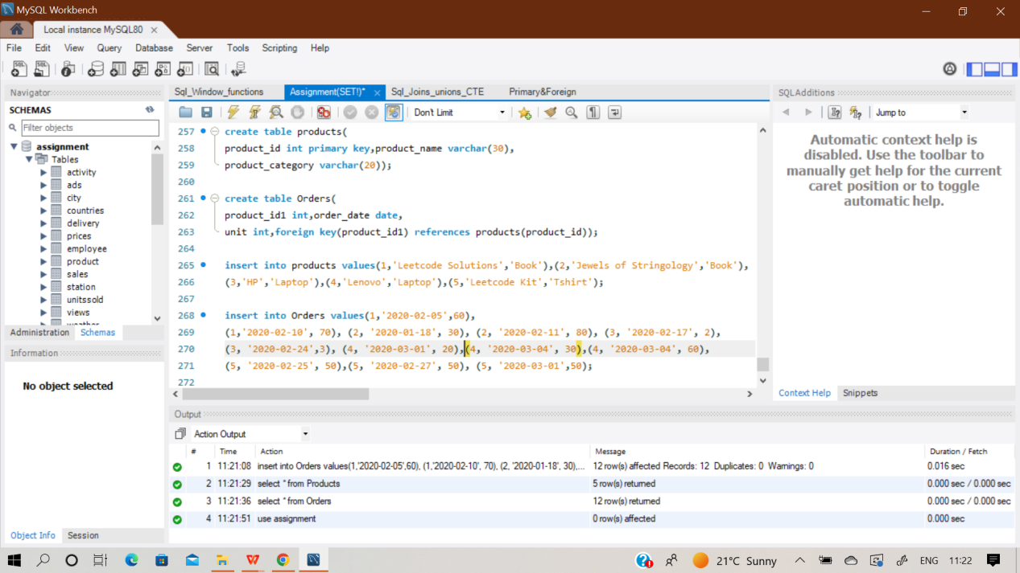

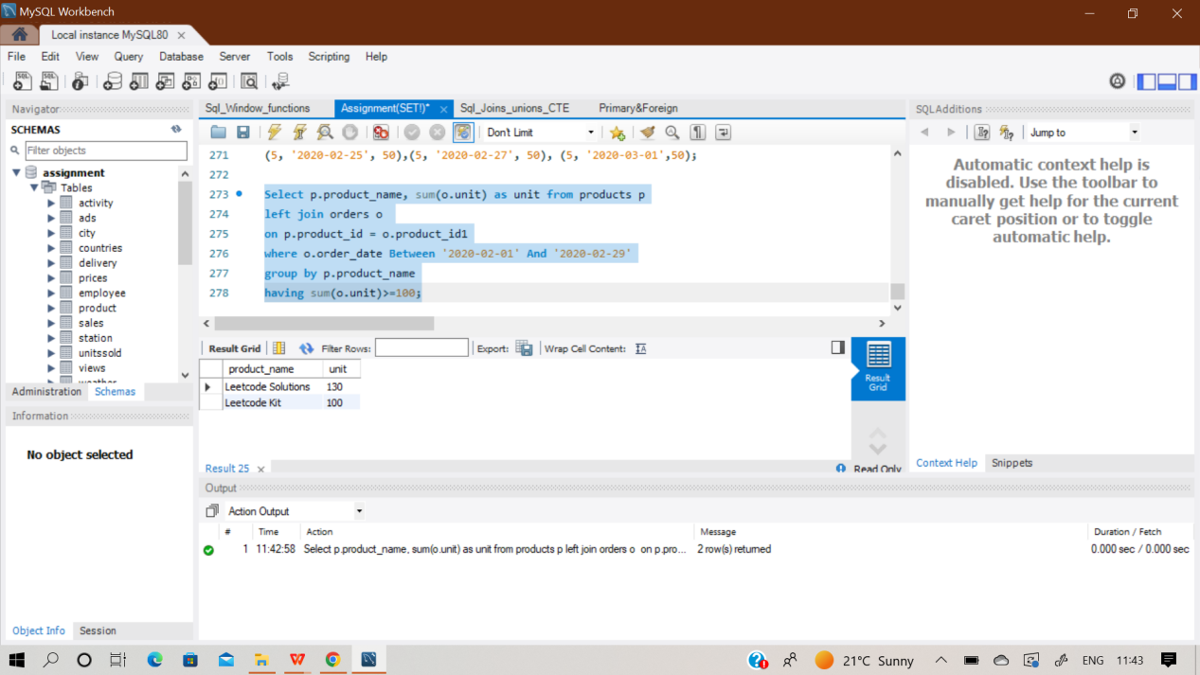

**Q27) Input:**

**Users Table**

|  |  |
| --- | --- |
| **Column Name** | **Type** |
| user_id | int |
| name | varchar |
| mail | varchar |

user_id is the primary key for this table.

This table contains information of the users signed up in a website. Some emails are invalid.

Write an SQL query to find the users who have valid emails.

A valid e-mail has a prefix name and a domain where:

● The prefix name is a string that may contain letters (upper or lower case), digits, underscore

'_', period '.', and/or dash '-'. The prefix name must start with a letter.

● The domain is '@leetcode.com'.

Return the result table in any order.

The query result format is in the following example

**Sol)** Create an empty table ‘Users’ and then inserted the records manually row by row.

Then performed the desired query.

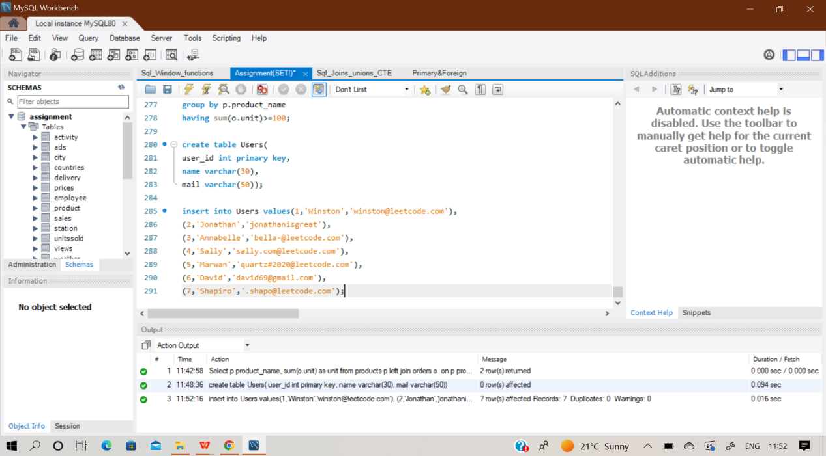

**select \***

**from users**

**where regexp_like(mail, '^[a-za-z][a-za-z0-9\_\.\-]*@leetcode.com');**

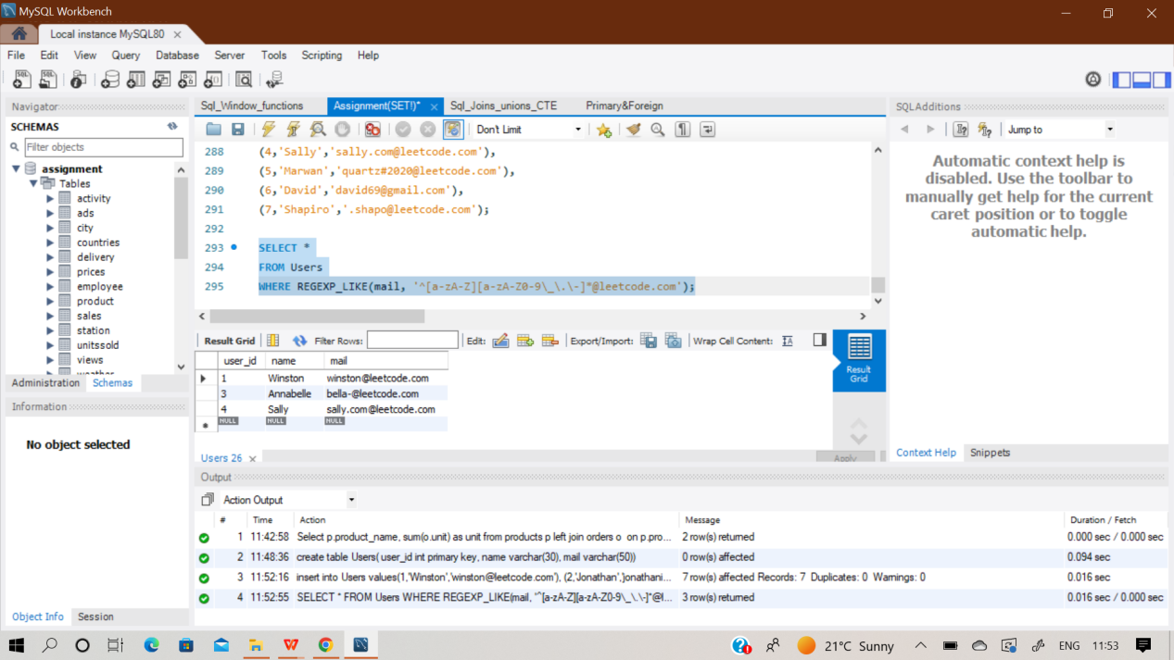

**Q28) Write an SQL query to report the customer_id and customer_name of customers who have spent at least $100 in each month of June and July 2020. Return the result table in any order.**

**The query result format is in the following example**

**Sol) First of all , I have created 3 empty tables namely ‘Customers’,’Produkt’ and ‘Orders’. Then manually inserted records in it row by row and then performed the query. Here all the three tables are connected to each other, through some column.**

**We have to use it as a condition and find the desired output.**

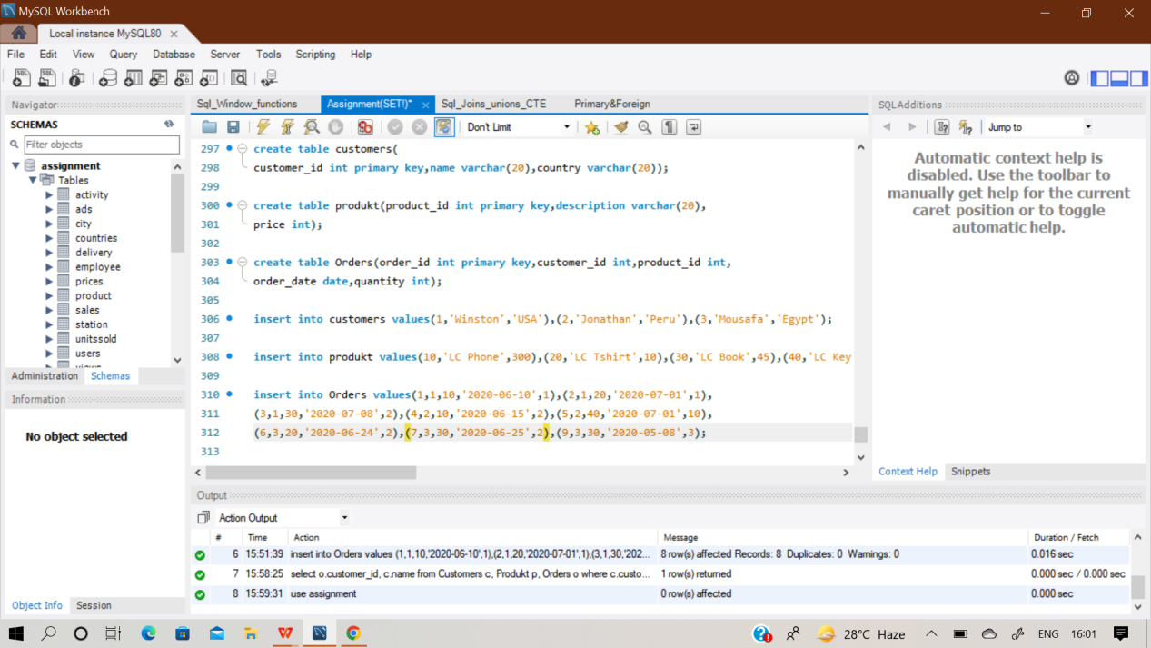

**select o.customer_id, c.name**

**from Customers c, Produkt p, Orders o**

**where c.customer_id = o.customer_id and p.product_id = o.product_id**

**group by o.customer_id**

**having (**

**sum(case when o.order_date like '2020-06%' then o.quantity*p.price else 0 end) >= 100**

**and**

**sum(case when o.order_date like '2020-07%' then o.quantity*p.price else 0 end) >= 100);**

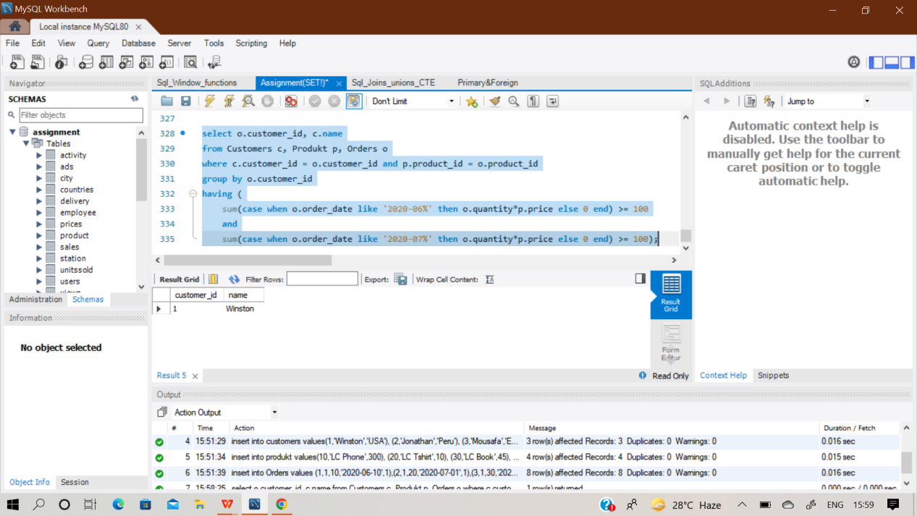

**Q29) Input:**

**Table: TVProgram**

|  |  |
| --- | --- |
| **Column Name** | **Type** |
| program_date | date |
| content_id | int |
| channel | varchar |

**Table: Content**

|  |  |
| --- | --- |
| **Column Name** | **Type** |
| content_id | varchar |
| title | varchar |
| Kids_content | enum |
| content_type | varchar |

**Write an SQL query to report the distinct titles of the kid-friendly movies streamed in June 2020. Return the result table in any order.**

**The query result format is in the following example.**

Sol) Create an empty table ‘TvProgram’ and ‘Content’ then inserted the records manually row by row.Then performed the desired query.

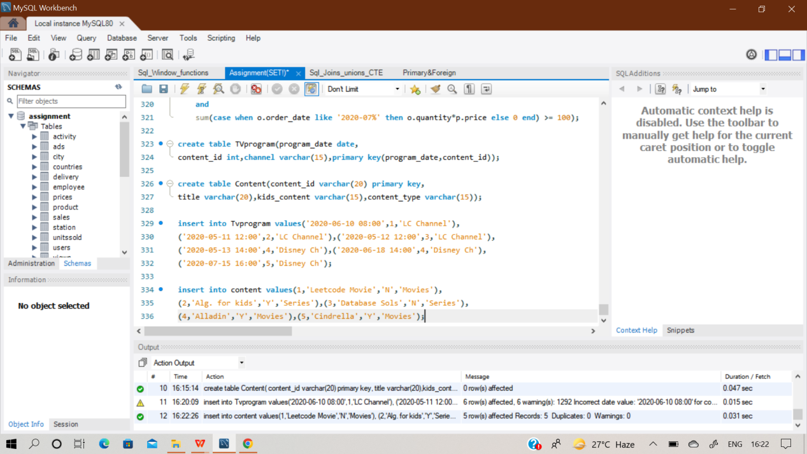

**Select distinct(title) from content c**

**join Tvprogram t on c.content_id=t.content_id**

**where c.kids_content = 'Y' and c.content_type = 'Movies'**

**and (month(program_date), year(program_date)) = (6, 2020);**

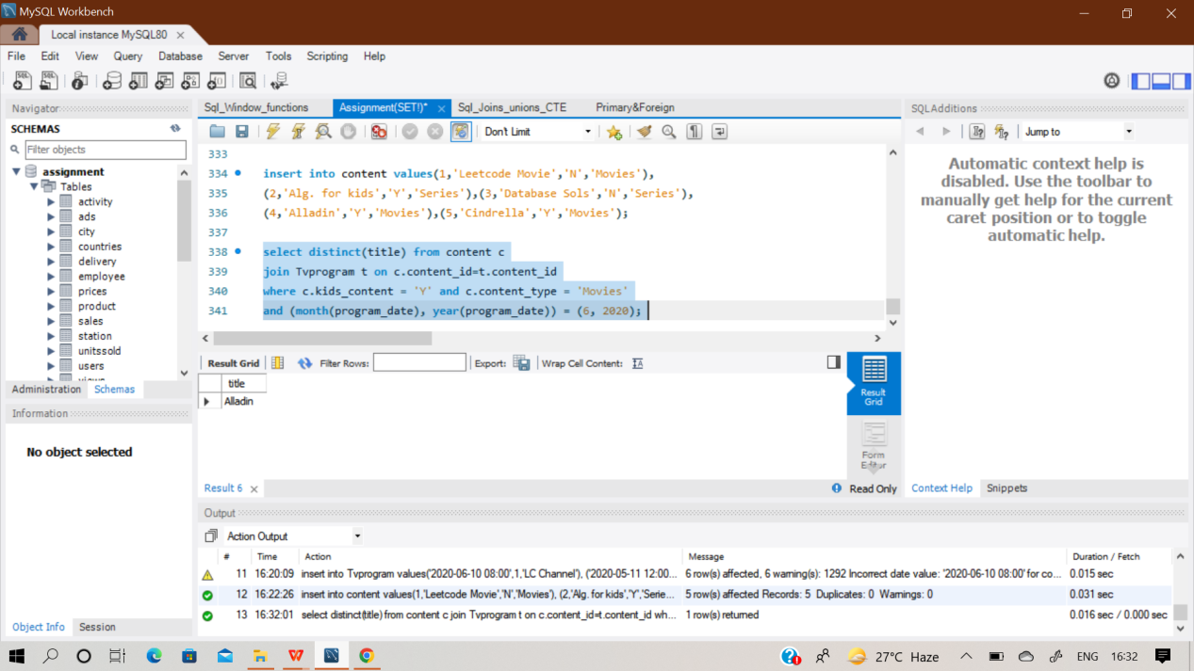

**Q30) Table: NPV**

|  |  |
| --- | --- |
| **Column Name** | **Type** |
| id | int |
| year | int |
| npv | int |

(id, year) is the primary key of this table.

**Table: Queries**

|  |  |
| --- | --- |
| **Column Name** | **Type** |
| id | int |
| year | int |

**Write an SQL query to find the npv of each query of the Queries table.**

**Return the result table in any order. The query result format is in the following example.**

Sol) Create two empty table ‘NPV’ and ‘Queries’ then inserted the records manually row by row.Then performed the desired query.

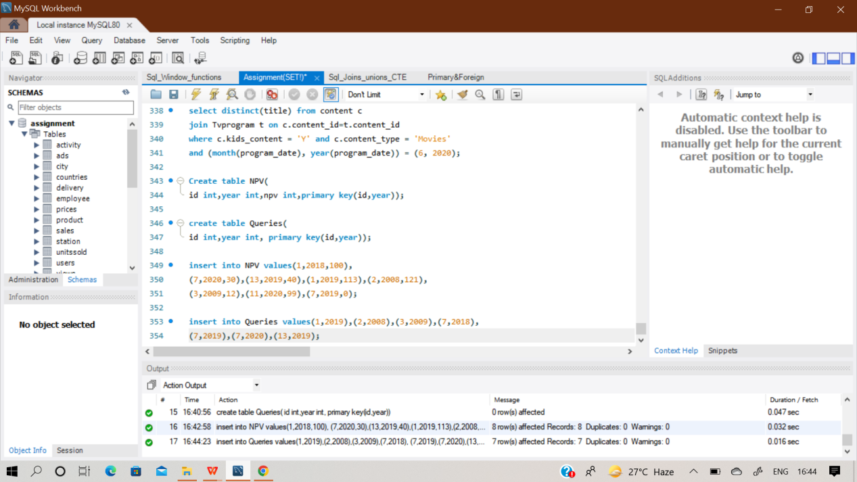

**Select q.id,q.year,n.npv from queries q left join NPV n**

**on q.id = n.id and n.year = q.year;**

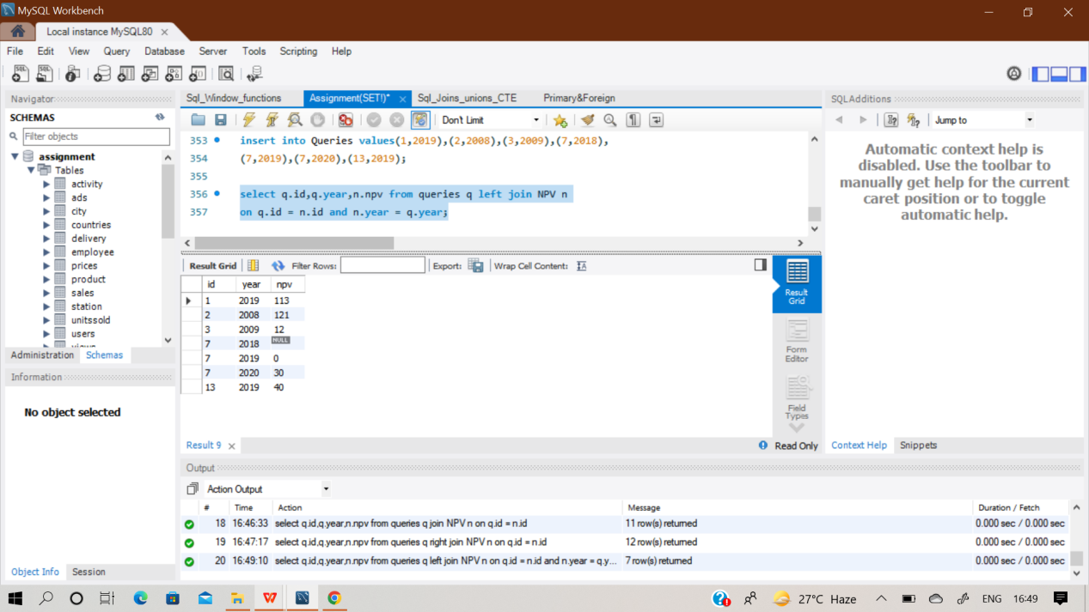

**Q31) SAME QUESTION AS Q30**

**Q32) Table: Employees**

|  |  |
| --- | --- |
| **Column Name** | **Type** |
| id | int |
| name | varchar |

id is the primary key for this table.

Each row of this table contains the id and the name of an employee in a company.

**Table: EmployeeUNI**

|  |  |
| --- | --- |
| **Column Name** | **Type** |
| id | int |
| unique_id | int |

(id, unique_id) is the primary key for this table.

**Write an SQL query to show the unique ID of each user, If a user does not have a unique ID replace just show null.**

**Sol)** Create two empty table ‘Employees’ and ‘EmployeesUNI’ then inserted the records manually row by row.Then performed the desired query.

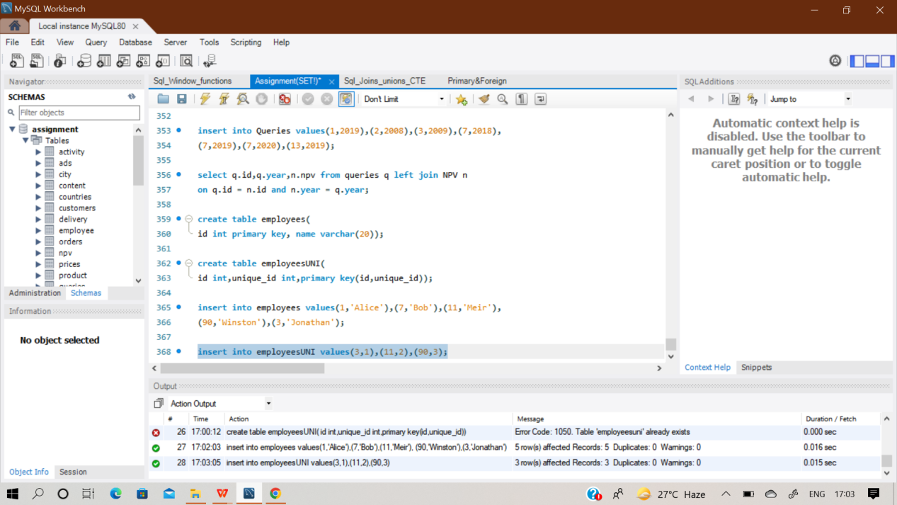

In this query, I have used Left join function because it is asked to show null values if a user does not have unique id.

**SELECT b.unique_id, a.name**

**FROM employees a**

**LEFT JOIN employeesUNI b on a.id = b.id;**

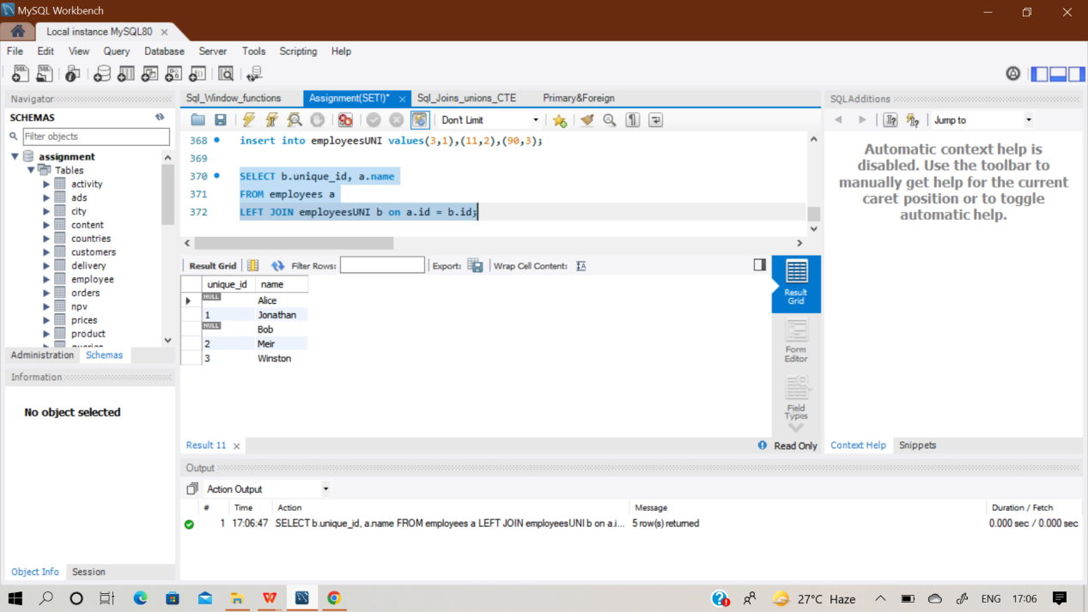

**Q33) Table: Users**

|  |  |
| --- | --- |
| **Column Name** | **Type** |
| id | int |
| name | varchar |

id is the primary key for this table. name is the name of the user.

**Table: Rides**

|  |  |
| --- | --- |
| **Column Name** | **Type** |
| id | int |
| user_id | int |
| distance | int |

id is the primary key for this table.

user_id is the id of the user who travelled the distance "distance".

**Write an SQL query to report the distance travelled by each user.**

**Return the result table ordered by travelled_distance in descending order, if two or more users travelled the same distance, order them by their name in ascending order. The query result format is in the following example**

**Sol)** Create two empty table ‘Users’ and ‘Rides’ then inserted the records manually row by row.Then performed the desired query.

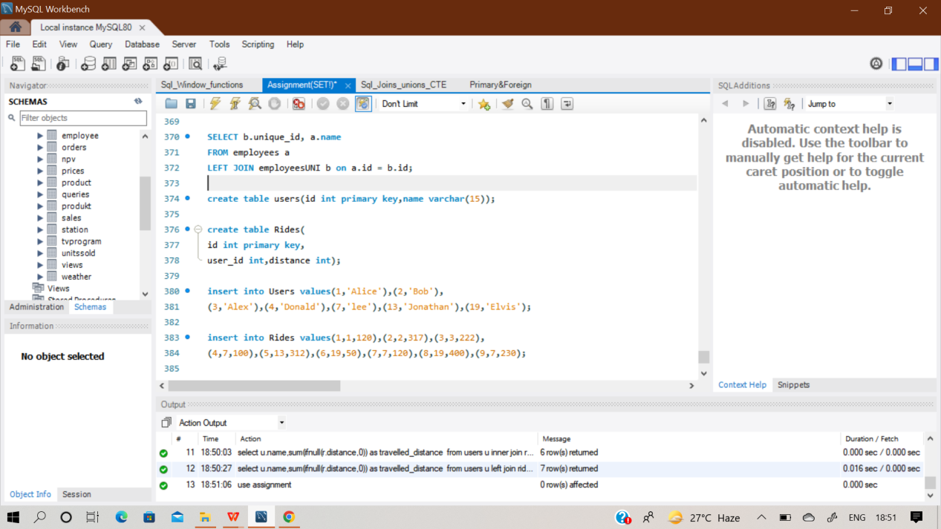

**select u.name,sum(ifnull(r.distance,0)) as travelled_distance**

**from users u**

**left join rides r**

**on u.id = r.user_id**

**group by u.name**

**order by travelled_distance desc,u.name asc;**

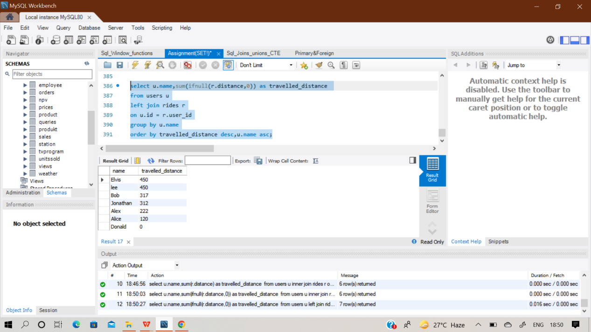

**Q34) SAME QUESTION AS Q26**

**Q35)** Table: Movies

|  |  |
| --- | --- |
| Column Name | Type |
| movie_id | int |
| title | varchar |

Table: Users

|  |  |
| --- | --- |
| Column Name | Type |
| user_id | int |
| name | varchar |

Table: MovieRating

|  |  |
| --- | --- |
| Column Name | Type |
| movie_id | int |
| user_id | int |
| rating | int |
| created_at | date |

**Write an SQL query to:**

* **Find the name of the user who has rated the greatest number of movies. In case of a tie, return the lexicographically smaller user name.**
* **Find the movie name with the highest average rating in February 2020. In case of a tie, return the lexicographically smaller movie name.**

**Sol)** Create three empty table ‘Movies’,’Users’ and ‘Movierating’ then inserted the records manually row by row.Then performed the desired query.

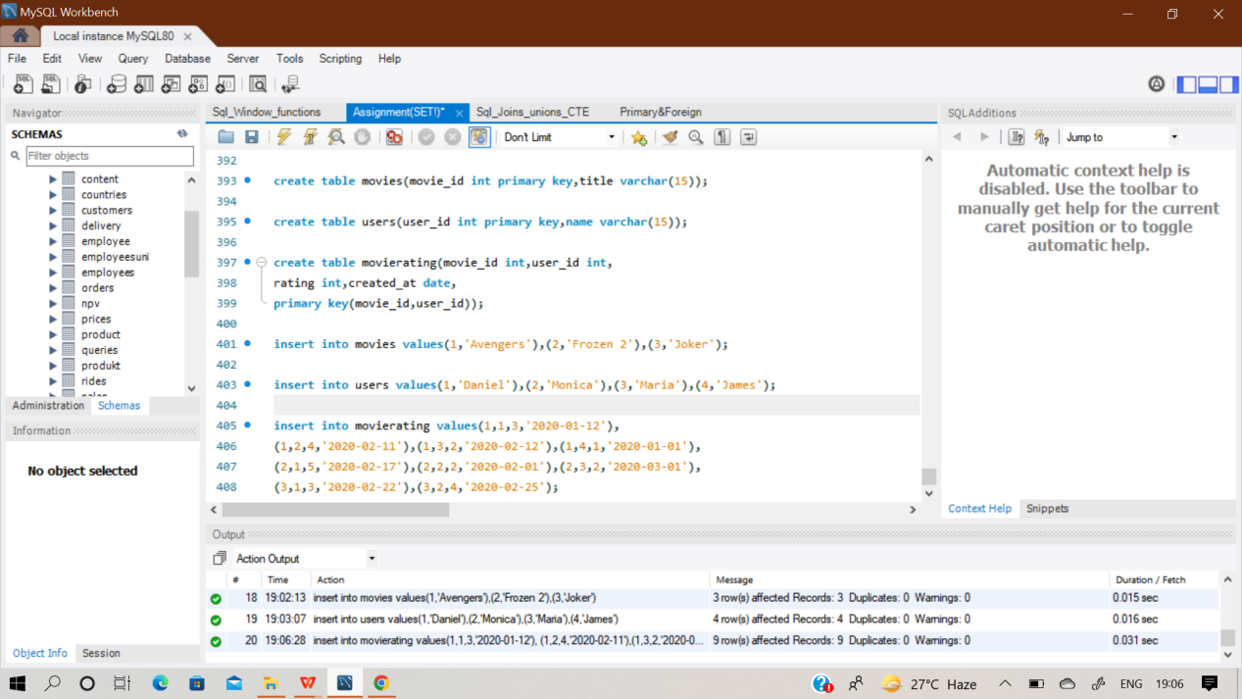

**(select b.name as results from users b**

**join movierating c on b.user_id=c.user_id**

**group by b.user_id**

**order by count(*) desc,b.name asc limit 1)**

**UNION**

**(select a.title as results from movies a**

**join movierating c on a.movie_id=c.movie_id**

**where (month(c.created_at), year(c.created_at)) = (2, 2020)**

**group by c.movie_id**

**order by avg(c.rating) desc,a.title asc limit 1);**

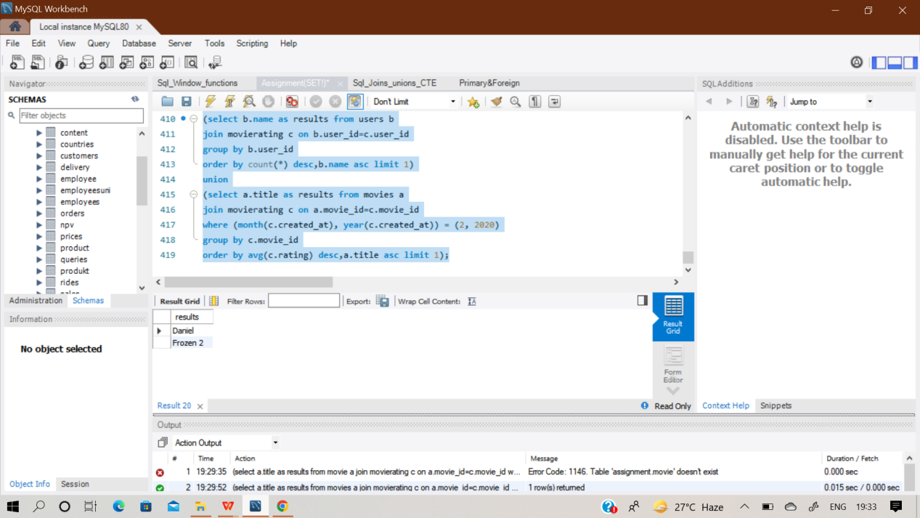

**Q36) SAME QUESTION AS Q33**

**Q37) SAME QUESTION AS Q32**

**Q38) Table: Departments**

|  |  |
| --- | --- |
| **Column Name** | **Type** |
| id | int |
| name | varchar |

id is the primary key of this table.The table has information about the id of each department of a university.

**Table: Students**

|  |  |
| --- | --- |
| **Column Name** | **Type** |
| id | int |
| name | varchar |
| department_id | int |

id is the primary key of this table. The table has information about the id of each student at a university and the id of the department he/she studies at.

**Write an SQL query to ﬁnd the id and the name of all students who are enrolled in departments that no longer exist. Return the result table in any order.**

**Sol)** Create two empty table ‘Departments’ and ‘Student’ then inserted the records manually row by row.Then performed the desired query.

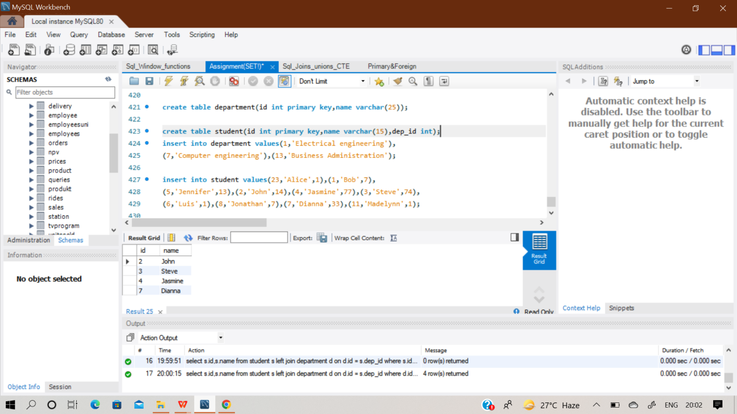

**select s.id,s.name from student s**

**left join department d on d.id = s.dep_id**

**where d.id is null;**

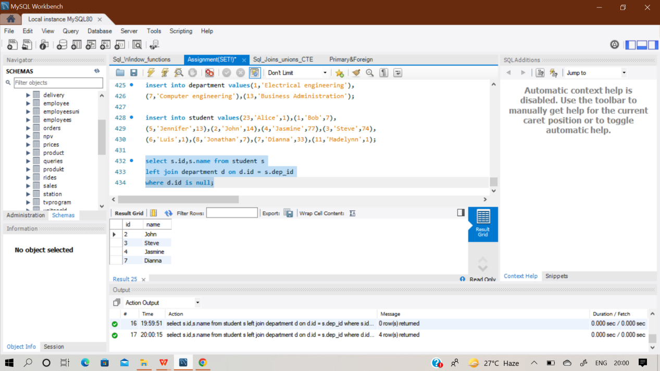

**Q39) Table: Calls**

|  |  |
| --- | --- |
| **Column Name** | **Type** |
| from_id | int |
| to_id | int |
| duration | int |

This table does not have a primary key, it may contain duplicates.

This table contains the duration of a phone call between from_id and to_id. from_id != to_id

**Write an SQL query to report the number of calls and the total call duration between each pair of distinct persons (person1, person2) where person1 < person2.**

**Sol)** Create an empty table ‘Calls’ then inserted the records manually row by row.Then performed the desired query.

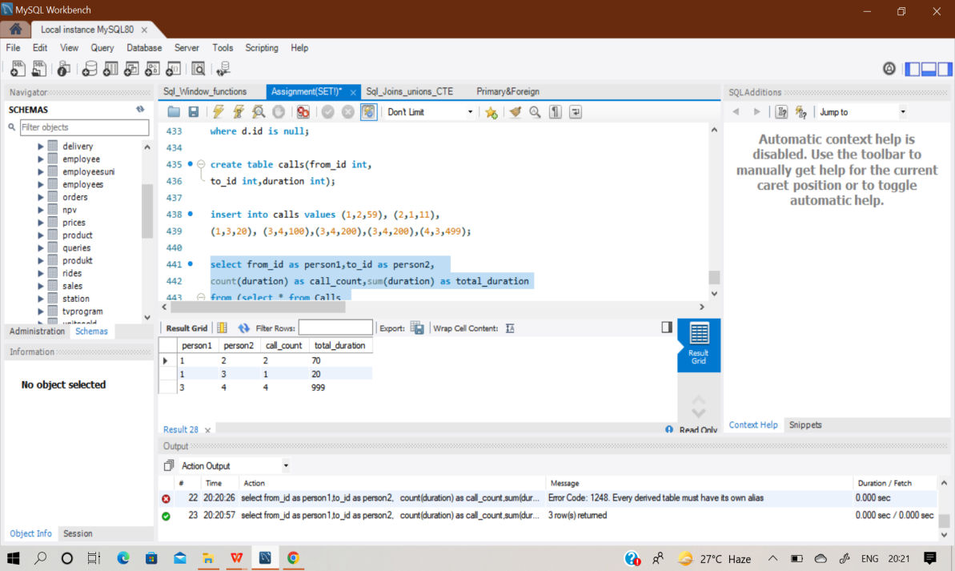

**Select from_id as person1,to_id as person2,**

**Count(duration) as call_count,sum(duration) as total_calls**

**From (select * from calls**

**Union all**

**Select to_id,from_id,duration**

**From calls) as a**

**Where from_id < to_id**

**Group by person1,person2;**

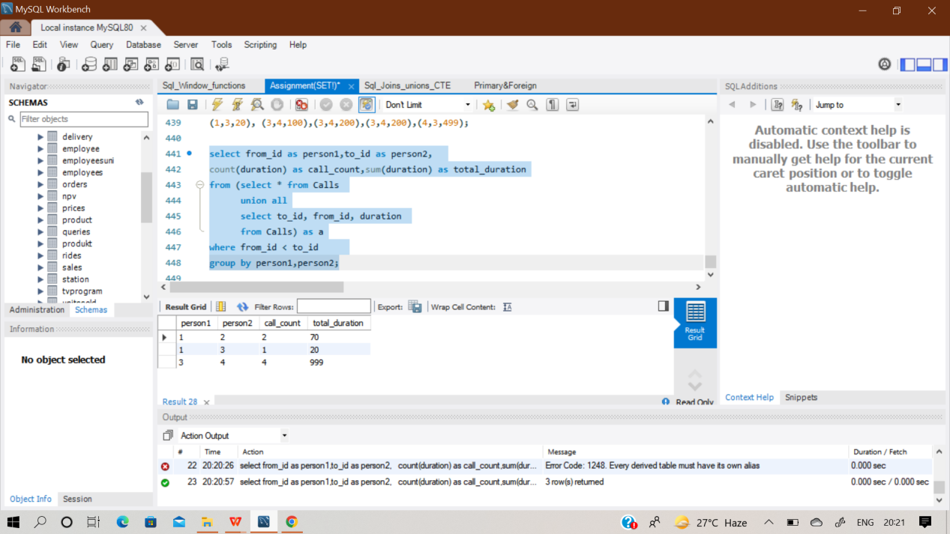

**Q40) SAME QUESTION AS Q23**

# Q41.

**Table: Warehouse**

|  |  |
| --- | --- |
| **Column Name** | **Type** |
| name | varchar |
| product_id | int |
| units | int |

(name, product_id) is the primary key for this table.Each row of this table contains the information of the products in each warehouse.

**Table: Products**

|  |  |
| --- | --- |
| **Column Name** | **Type** |
| product_id | int |
| product_name | varchar |
| Width | int |
| Length | int |
| Height | int |

product_id is the primary key for this table.Each row of this table contains information about the product dimensions (Width, Length, and Height) in feets of each product.

**Write an SQL query to report the number of cubic feet of volume the inventory occupies in each warehouse. Return the result table in any order.The query result format is in the following example.**

**Sol)** Create two empty table ‘Warehouse’ and ‘Products’ then inserted the records manually row by row.Then performed the desired query.

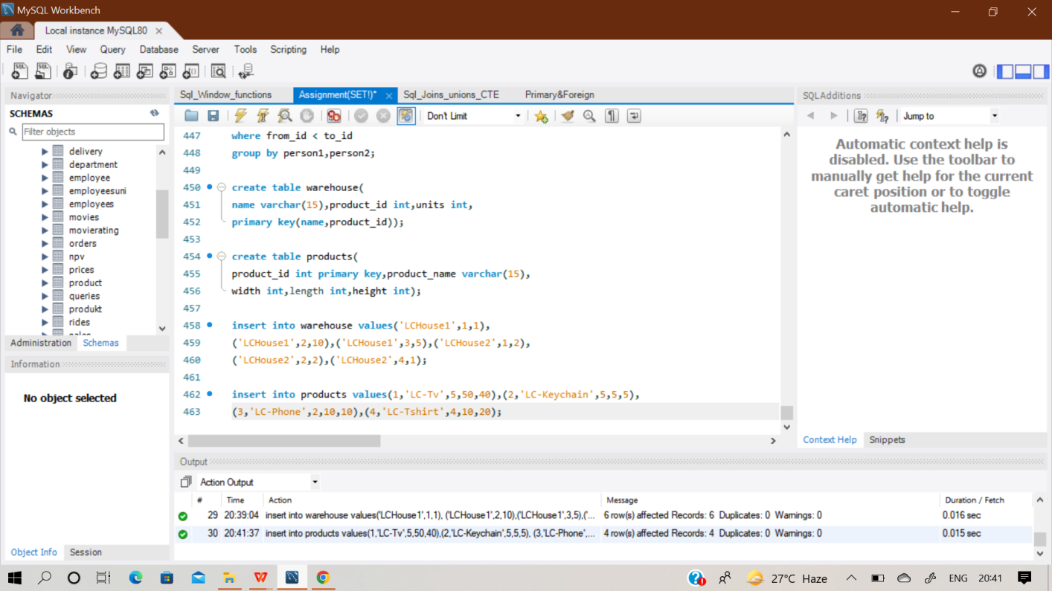

**select name as warehouse_name,**

**sum(units*width*length*height) as volume**

**from warehouse w**

**inner join products p on w.product_id = p.product_id**

**group by name**

**order by null;**

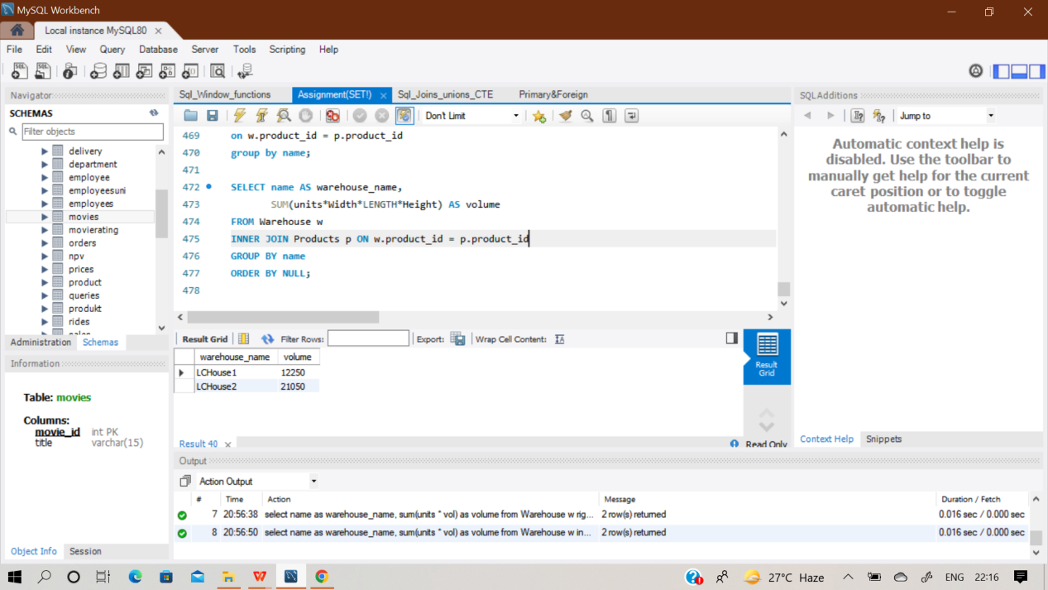

**Q42) Table: Sales**

|  |  |
| --- | --- |
| **Column Name** | **Type** |
| sale_date | date |
| fruit | enum |
| sold_num | int |

(sale_date, fruit) is the primary key for this table.

This table contains the sales of "apples" and "oranges" sold each day.

**Write an SQL query to report the difference between the number of apples and oranges sold each day. Return the result table ordered by sale_date.**

**The query result format is in the following example**

**Sol) create an empty table ‘sales’ and insert records inside it row by row manually. And then perform the desired query in it.**

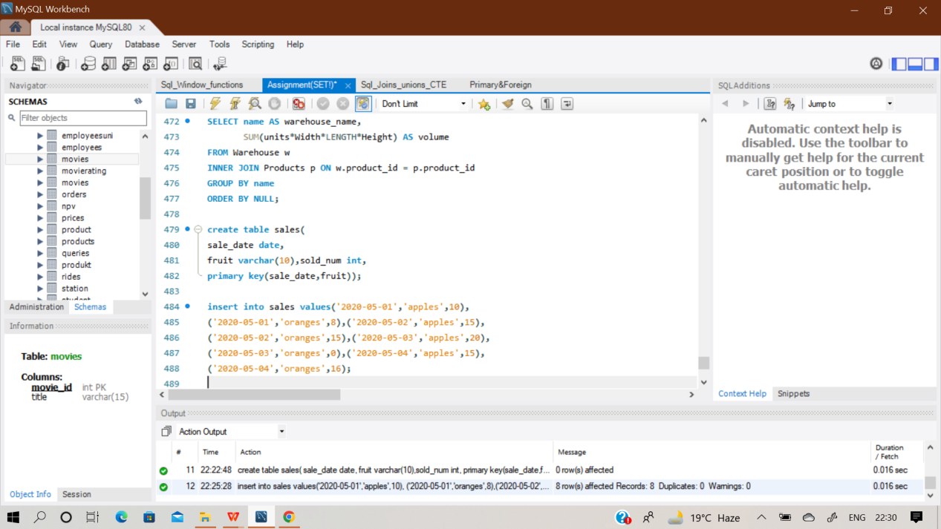

**select sale_date,**

**SUM(case when fruit='apples' then sold_num**

**else -sold_num**

**end) as diff**

**from sales**

**group by sale_date order by sale_date;**

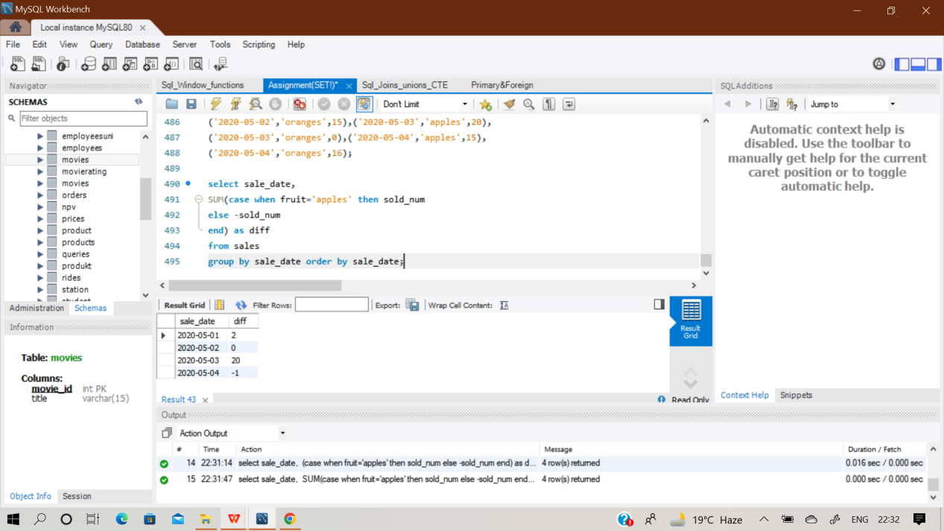

**Q43) Table: Activity**

|  |  |
| --- | --- |
| **Column Name** | **Type** |
| player_id | int |
| device_id | int |
| event_date | date |
| games_played | int |

(player_id, event_date) is the primary key of this table. This table shows the activity of players of some games. Each row is a record of a player who logged in and played a number of games (possibly 0) before

logging out on someday using some device.

**Write an SQL query to report the fraction of players that logged in again on the day after the day they first logged in, rounded to 2 decimal places. In other words, you need to count the number of players that logged in for at least two consecutive days starting from their first login date, then divide that number by the total number of play.**

**Sol) create an empty table ‘Activity’ and insert records inside it row by row manually. And then perform the desired query in it.**

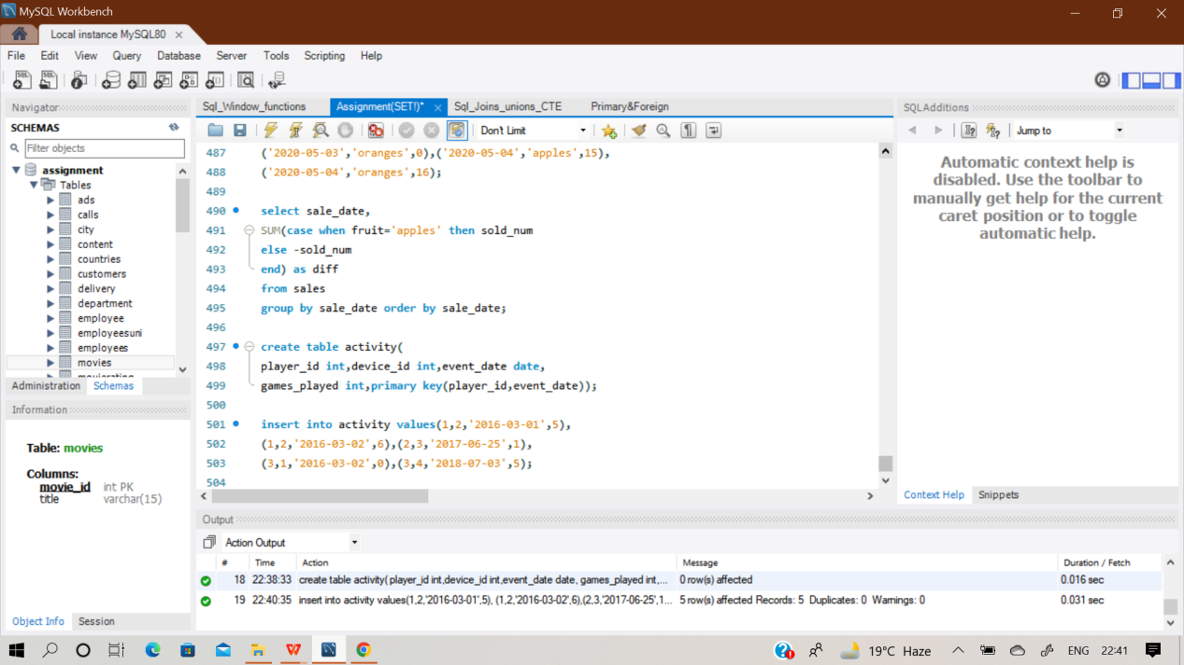

**with activity_stats as (**

**select player_id, event_date,**

**datediff(event_date,min(event_date) over(partition by player_id)) as date_diff**

**from activity)**

**select round(count(distinct player_id) / (select count(distinct player_id)**

**from activity), 2) as fraction**

**from activity_stats**

**where date_diff = 1;**

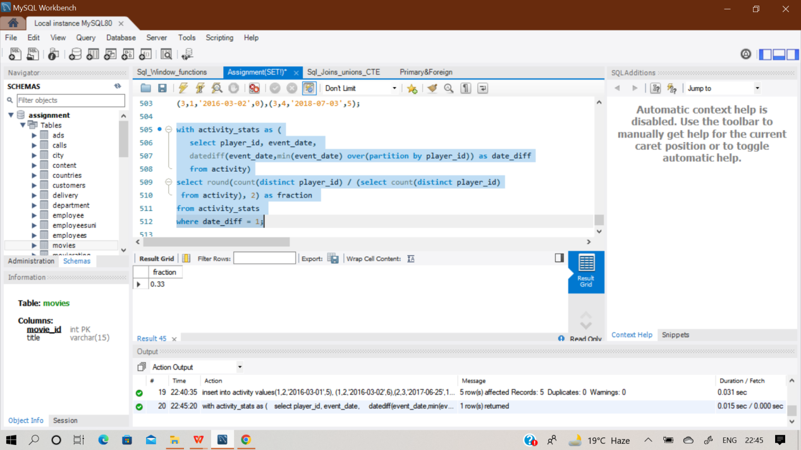

**Q44) Table: Employee**

|  |  |
| --- | --- |
| **Column Name** | **Type** |
| id | int |
| name | varchar |
| department | varchar |
| managerId | int |

id is the primary key column for this table.

Each row of this table indicates the name of an employee, their department, and the id of their manager.If manager_Id is null, then the employee does not have a manager. No employee will be the manager of themself.

**Write an SQL query to report the managers with at least five direct reports. Return the result table in any order. The query result format is in the following example.**

**Sol) create an empty table ‘Employee’ and insert records inside it row by row manually. And then perform the desired query in it.**

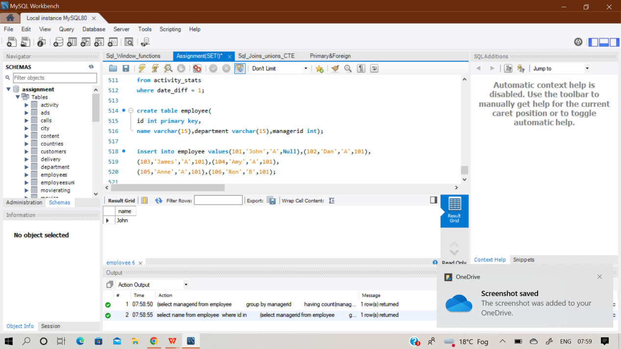

**select name from employee**

**where id in**

**(select managerid from employee**

**group by managerid**

**having count(managerid)>=5);**

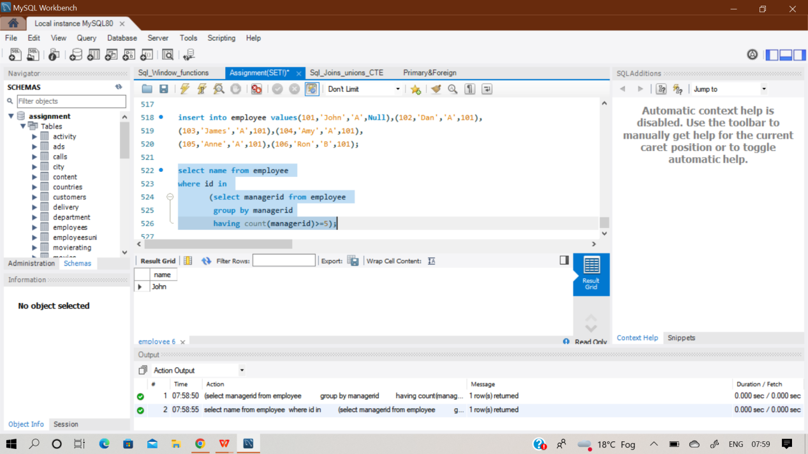

**Q45) Table: Student**

|  |  |
| --- | --- |
| **Column Name** | **Type** |
| student_id | int |
| student_name | varchar |
| gender | varchar |
| dept_id | int |

student_id is the primary key column for this table.dept_id is a foreign key to dept_id in the Department tables.Each row of this table indicates the name of a student, their gender, and the id of their department.

**Table: Department**

|  |  |
| --- | --- |
| **Column Name** | **Type** |
| dept_id | int |
| dept_name | varchar |

dept_id is the primary key column for this table. Each row of this table contains the id and the name of a department.

**Write an SQL query to report the respective department name and number of students majoring in each department for all departments in the Department table (even ones with no current students). Return the result table ordered by student_number in descending order. In case of a tie, order them by dept_name alphabetically. The query result format is in the following example.**

**Sol) create two empty table ‘Student’ & ‘Employee’ and insert records inside it row by row manually. And then perform the desired query in it.**

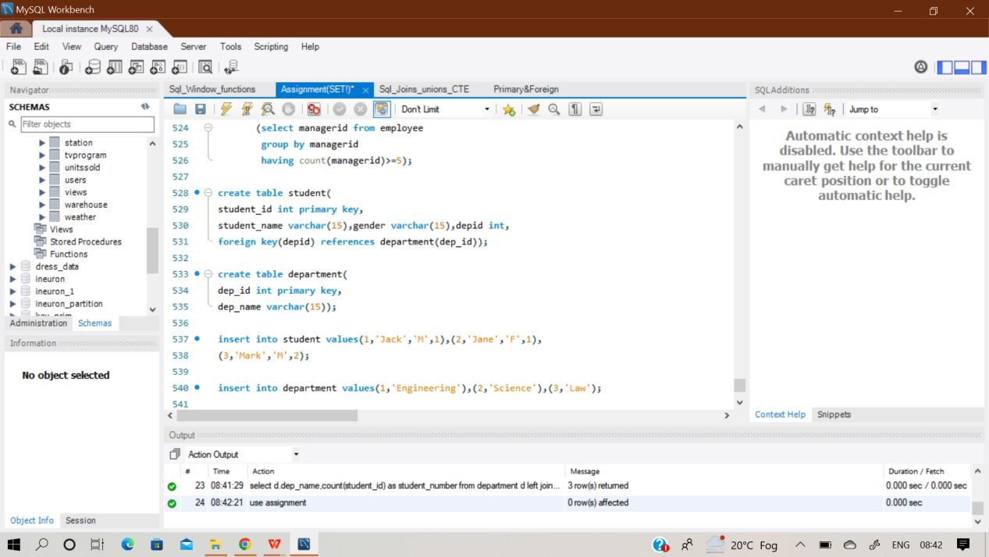

**select d.dep_name,count(student_id) as student_number**

**from department d left join student s**

**on d.dep_id = s.depid**

**group by d.dep_id**

**order by student_number desc,d.dep_name asc;**

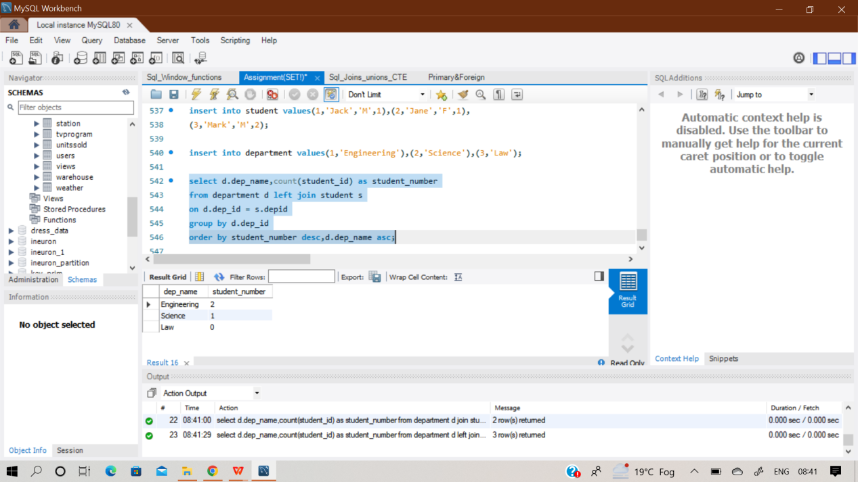

**Q46)**

**Table: Customer**

|  |  |
| --- | --- |
| **Column Name** | **Type** |
| customer_id | int |
| product_key | int |

There is no primary key for this table. It may contain duplicates. Product_key is a foreign key to the Product table.

**Table: Product**

|  |  |
| --- | --- |
| **Column Name** | **Type** |
| product_key | int |

Product_key is a primary key for this table.

**Write an SQL query to report the customer ids from the Customer table that bought all the products in the Product table. Return the result table in any order. The query result format is in the following example.**

**Sol) create two empty table ‘Student’ & ‘Employee’ and insert records inside it row by row manually. And then perform the desired query in it.**

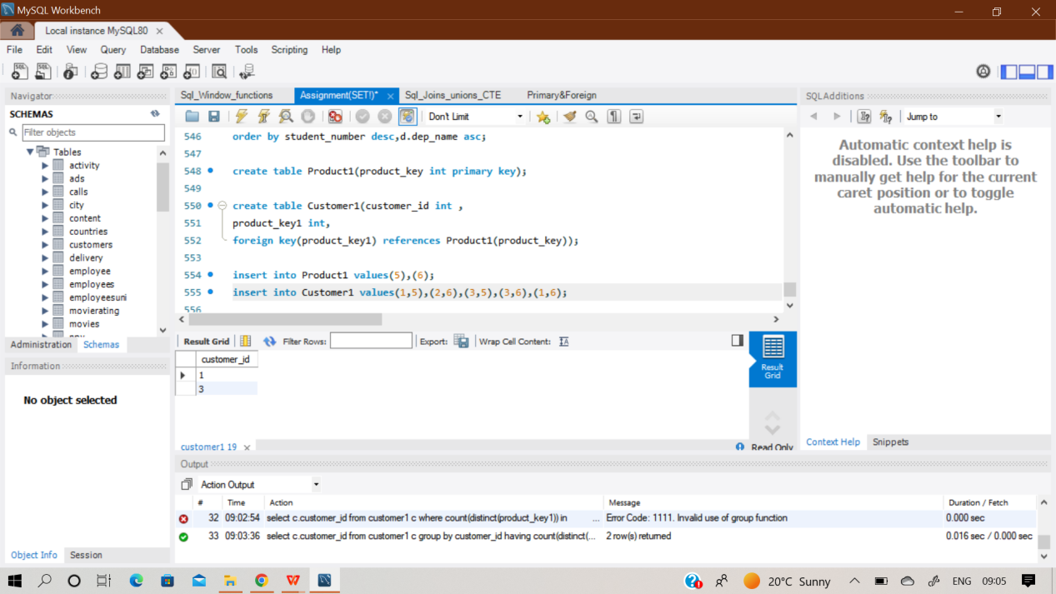

**select c.customer_id from customer1 c**

**group by customer_id**

**having count(distinct(product_key1)) in**

**(select count(product_key) from product1);**

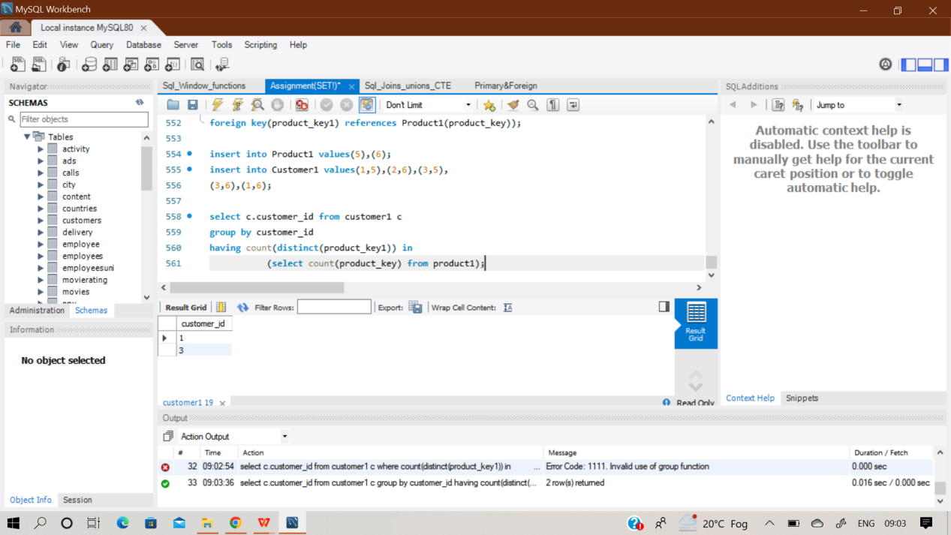

**Q47) Table: Project**

|  |  |
| --- | --- |
| **Column Name** | **Type** |
| Project_id | int |
| Employee_id | int |

(project_id, employee_id) is the primary key of this table.

employee_id is a foreign key to the Employee table. Each row of this table indicates that the employee with employee_id is working on the project with project_id.

**Table: Employee**

|  |  |
| --- | --- |
| **Column Name** | **Type** |
| employee_id | int |
| name | varchar |
| experience_yea rs | int |

employee_id is the primary key of this table. Each row of this table contains information about one employee.

**Write an SQL query that reports the most experienced employees in each project. In case of a tie, report all employees with the maximum number of experience years. Return the result table in any order. The query result format is in the following example.**

**Sol) create two empty table ‘Project’ & ‘Employee’ and insert records inside it row by row manually. And then perform the desired query in it.**

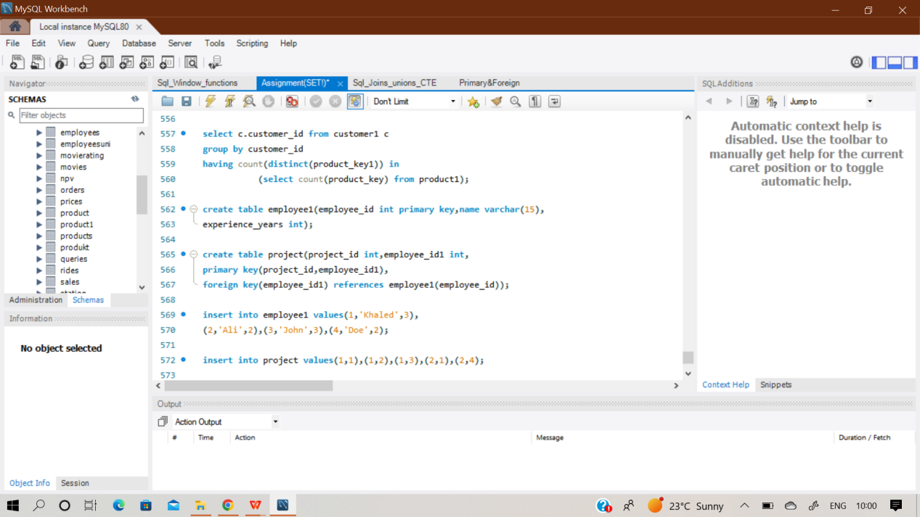

**Select project_id,employee_id1 FROM (**

**SELECT p.project_id, p.employee_id1,**

**DENSE_RANK() OVER(PARTITION BY p.project_id ORDER BY e.experience_years DESC) as rnk**

**FROM project p JOIN employee1 as e**

**ON p.employee_id1 = e.employee_id**

**) as a**

**WHERE rnk = 1;**

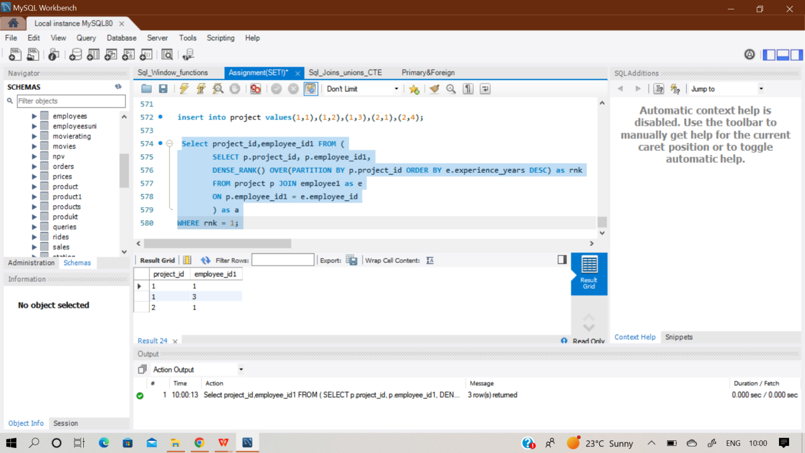

Q48) Table: Books

|  |  |
| --- | --- |
| Column Name | Type |
| book_id | int |
| name | varchar |
| available_from | date |

book_id is the primary key of this table.

Table: Orders

|  |  |
| --- | --- |
| Column Name | Type |
| order_id | int |
| book_id | int |
| quantity | int |
| dispatch_date | date |

order_id is the primary key of this table. Book_id is a foreign key to the Books table.

**Write an SQL query that reports the books that have sold less than 10 copies in the last year, excluding books that have been available for less than one month from today. Assume today is 2019-06-23.**

**Return the result table in any order. The query result format is in the following example.**

.**Sol) create two empty table ‘Books’ & ‘Orders’ and insert records inside it row by row manually. And then perform the desired query in it.**

ORDER table missing in question.

# Q49.

Table: Enrollments

|  |  |
| --- | --- |
| Column Name | Type |
| student_id | int |
| course_id | int |
| grade | int |

(student_id, course_id) is the primary key of this table.

**Write a SQL query to ﬁnd the highest grade with its corresponding course for each student. In case of a tie, you should ﬁnd the course with the smallest course_id.Return the result table ordered by student_id in ascending order. The query result format is in the following example.**

.**Sol) create an empty table ‘Enrollments’ and insert records inside it row by row manually. And then perform the desired query in it.**

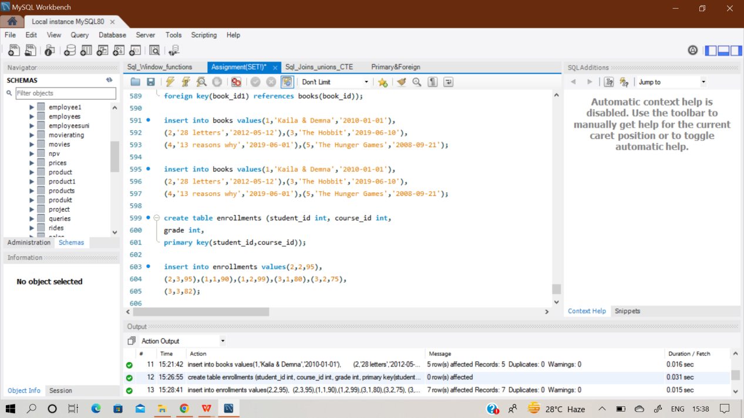

**select student_id, min(course_id) as course_id, grade**

**from Enrollments**

**where (student_id, grade) in**

**(select student_id, max(grade)**

**from Enrollments**

**group by student_id)**

**group by student_id**

**order by student_id asc;**

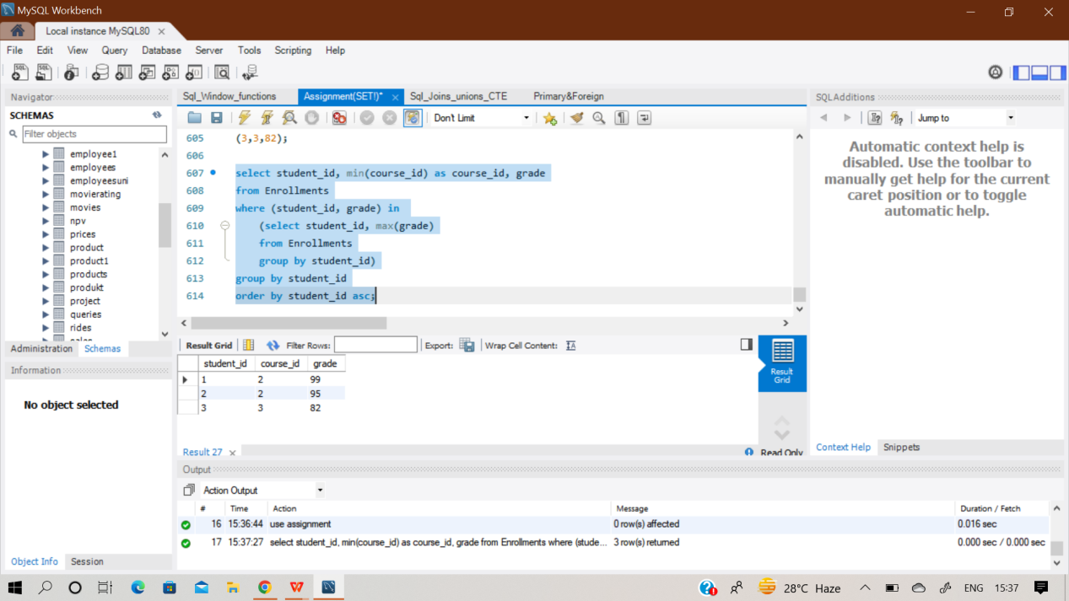

**Q50)**

**Table: Players**

|  |  |
| --- | --- |
| **Column Name** | **Type** |
| player_id | int |
| Group_id | int |

team_id is the primary key of this table.Each row of this table represents a single football team.

**Table: Matches**

|  |  |
| --- | --- |
| **Column Name** | **Type** |
| match_id | int |
| host_team | int |
| guest_team | int |
| host_goals | int |
| guest_goals | int |

match_id is the primary key of this table.

Each row is a record of a ﬁnished match between two different teams. Teams host_team and guest_team are represented by their IDs in the Teams table (team_id), and they scored host_goals and guest_goals goals, respectively.The winner in each group is the player who scored the maximum total points within the group. In the case of a tie, the lowest player_id wins.

**Write an SQL query to find the winner in each group. Return the result table in any order. The query result format is in the following example.**

.**Sol) create two empty table ‘Players’ & Matches and insert records inside it row by row manually. And then perform the desired query in it.**

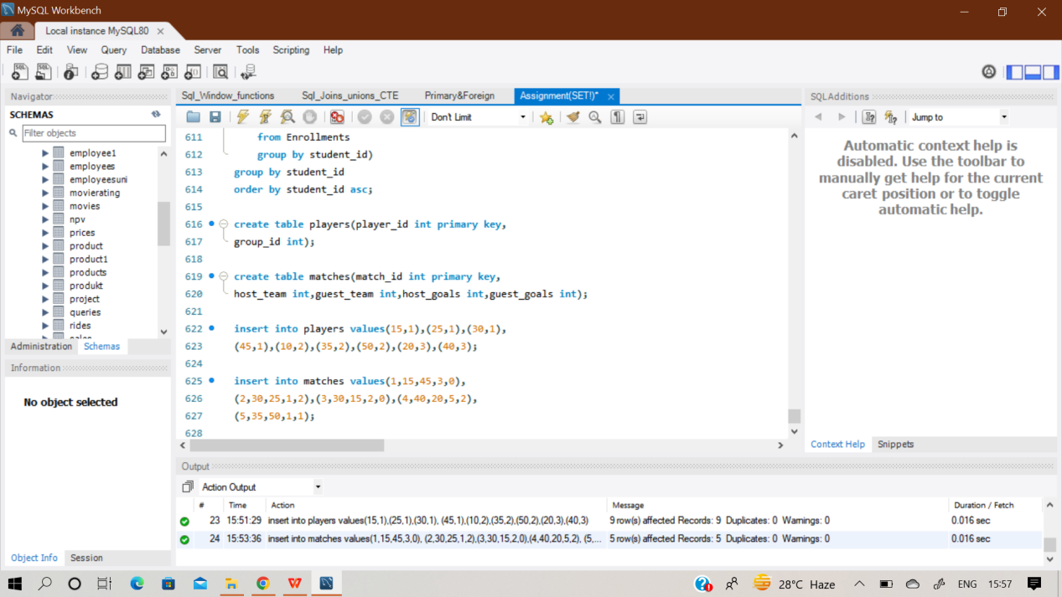

**select group_id, player_id from**

**(select p.group_id, ps.player_id,**

**sum(ps.score) as score**

**from players p inner join**

**(select first_player as player_id, first_score as score from matches**

**union all**

**select second_player as player_id,second_score as score**

**from matches) ps**

**on p.player_id = ps.player_id**

**group by ps.player_id**

**order by group_id, score desc, player_id) top_scores**

**group by group_id;**

